




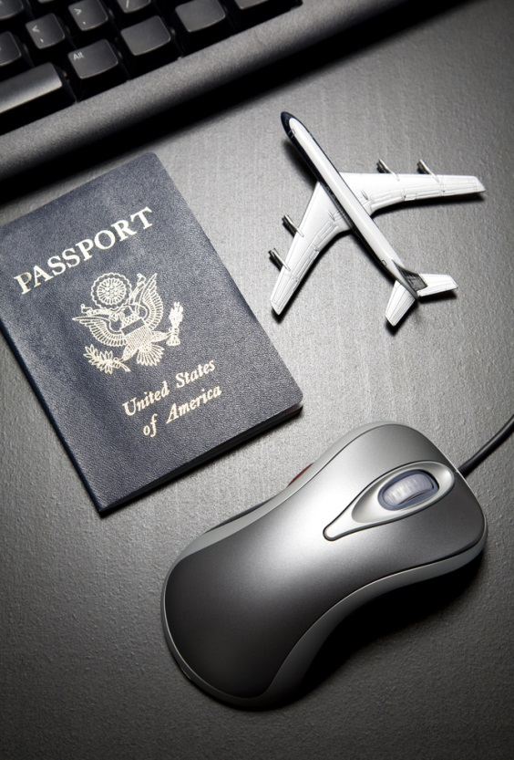

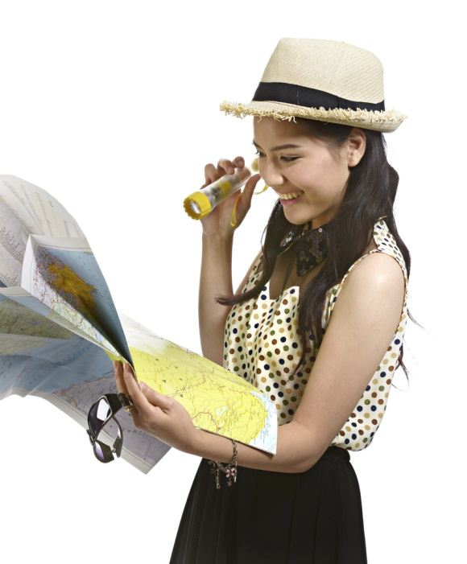
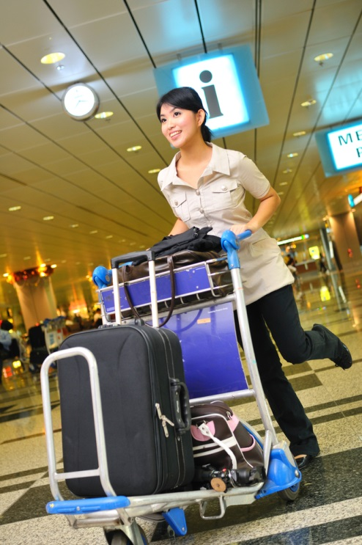
Lead tour groups in a responsible manner
D2.TTG.CL3.11
Trainee Manual

Lead tour groups in a responsible manner
D2.TTG.CL3.11
Trainee Manual





Project Base
William Angliss Institute of TAFE
555 La Trobe Street
Melbourne 3000 Victoria
Telephone: | (03) 9606 2111
Facsimile: | (03) 9670 1330
Acknowledgements
Project Director: | Wayne Crosbie
Project Manager | Jim Irwin
Chief Writer: | Alan Hickman
Subject Writer: | Nick Hyland
Editor: | Jim Irwin
DTP/Production: | Daniel Chee, Mai Vu, Cindy Curran

The Association of Southeast Asian Nations (ASEAN) was established on 8 August 1967. The Member States of the Association are Brunei Darussalam, Cambodia, Indonesia, Lao PDR, Malaysia, Myanmar, Philippines, Singapore, Thailand and Viet Nam.
The ASEAN Secretariat is based in Jakarta, Indonesia.
General Information on ASEAN appears online at the ASEAN Website: www.asean.org.
All text is produced by William Angliss Institute of TAFE for the ASEAN Project on “Toolbox Development for Tourism Labour Divisions for Travel Agencies and Tour Operations”.
This publication is supported by the Australian Government’s aid program through the ASEAN-Australia Development Cooperation Program Phase II (AADCP II).
Copyright: Association of Southeast Asian Nations (ASEAN) 2015.
All rights reserved.
Disclaimer
Every effort has been made to ensure that this publication is free from errors or omissions. However, you should conduct your own enquiries and seek professional advice before relying on any fact, statement or matter contained in this book. The ASEAN Secretariat and William Angliss Institute of TAFE are not responsible for any injury, loss or damage as a result of material included or omitted from this course. Information in this module is current at the time of publication. Time of publication is indicated in the date stamp at the bottom of each page.
Some images appearing in this resource have been purchased from stock photography suppliers Shutterstock and iStockphoto and other third party copyright owners and as such are non-transferable and non-exclusive. Clip arts, font images and illustrations used are from the Microsoft Office Clip Art and Media Library. Some images have been provided by and are the property of William Angliss Institute.
Additional images have been sourced from Flickr and SXC and are used under Creative Commons licence: http://creativecommons.org/licenses/by/2.0/deed.en

File name: TM_Lead tour groups in a resp manner_150115





Table of contents
Introduction to trainee manual 1
Unit descriptor 3
Assessment matrix 5
Glossary 7
Element 1: Identify the pre-requisites for responsible tour leadership 9
Element 2: Co-ordinate tour group movements and activities 41
Element 3: Facilitate tour group interaction with each other and the tour environment 79
Element 4: Deal with on-tour problems 93
Presentation of written work 113
Recommended reading 115
Trainee evaluation sheet 117
Trainee self-assessment checklist 119

Introduction to trainee manual

To the Trainee
Congratulations on joining this course. This Trainee Manual is one part of a ‘toolbox’ which is a resource provided to trainees, trainers and assessors to help you become competent in various areas of your work.
The ‘toolbox’ consists of three elements:
- A Trainee Manual for you to read and study at home or in class
- A Trainer Guide with Power Point slides to help your Trainer explain the content of the training material and provide class activities to help with practice
- An Assessment Manual which provides your Assessor with oral and written questions and other assessment tasks to establish whether or not you have achieved competency.
The first thing you may notice is that this training program and the information you find in the Trainee Manual seems different to the textbooks you have used previously. This is because the method of instruction and examination is different. The method used is called Competency based training (CBT) and Competency based assessment (CBA). CBT and CBA is the training and assessment system chosen by ASEAN (Association of South-East Asian Nations) to train people to work in the tourism and hospitality industry throughout all the ASEAN member states.
What is the CBT and CBA system and why has it been adopted by ASEAN?
CBT is a way of training that concentrates on what a worker can do or is required to do at work. The aim is of the training is to enable trainees to perform tasks and duties at a standard expected by employers. CBT seeks to develop the skills, knowledge and attitudes (or recognise the ones the trainee already possesses) to achieve the required competency standard. ASEAN has adopted the CBT/CBA training system as it is able to produce the type of worker that industry is looking for and this therefore increases trainees chances of obtaining employment.
CBA involves collecting evidence and making a judgement of the extent to which a worker can perform his/her duties at the required competency standard. Where a trainee can already demonstrate a degree of competency, either due to prior training or work experience, a process of ‘Recognition of Prior Learning’ (RPL) is available to trainees to recognise this. Please speak to your trainer about RPL if you think this applies to you.
What is a competency standard?
Competency standards are descriptions of the skills and knowledge required to perform a task or activity at the level of a required standard.
242 competency standards for the tourism and hospitality industries throughout the ASEAN region have been developed to cover all the knowledge, skills and attitudes required to work in the following occupational areas:
- Housekeeping
- Food Production
- Food and Beverage Service
- Front Office
- Travel Agencies
- Tour Operations.
All of these competency standards are available for you to look at. In fact you will find a summary of each one at the beginning of each Trainee Manual under the heading ‘Unit Descriptor’. The unit descriptor describes the content of the unit you will be studying in the Trainee Manual and provides a table of contents which are divided up into ‘Elements’ and ‘Performance Criteria”. An element is a description of one aspect of what has to be achieved in the workplace. The ‘Performance Criteria’ below each element details the level of performance that needs to be demonstrated to be declared competent.
There are other components of the competency standard:
- Unit Title: statement about what is to be done in the workplace
- Unit Number: unique number identifying the particular competency
- Nominal hours: number of classroom or practical hours usually needed to complete the competency. We call them ‘nominal’ hours because they can vary e.g. sometimes it will take an individual less time to complete a unit of competency because he/she has prior knowledge or work experience in that area.
The final heading you will see before you start reading the Trainee Manual is the ‘Assessment Matrix’. Competency based assessment requires trainees to be assessed in at least 2 – 3 different ways, one of which must be practical. This section outlines three ways assessment can be carried out and includes work projects, written questions and oral questions. The matrix is designed to show you which performance criteria will be assessed and how they will be assessed. Your trainer and/or assessor may also use other assessment methods including ‘Observation Checklist’ and ‘Third Party Statement’. An observation checklist is a way of recording how you perform at work and a third party statement is a statement by a supervisor or employer about the degree of competence they believe you have achieved. This can be based on observing your workplace performance, inspecting your work or gaining feedback from fellow workers.
Your trainer and/or assessor may use other methods to assess you such as:
- Journals
- Oral presentations
- Role plays
- Log books
- Group projects
- Practical demonstrations.
Remember your trainer is there to help you succeed and become competent. Please feel free to ask him or her for more explanation of what you have just read and of what is expected from you and best wishes for your future studies and future career in tourism and hospitality.

Unit descriptor
Lead tour groups in a responsible manner
This unit deals with the skills and knowledge required to Lead tour groups in a responsible manner in a range of settings within the tour industries workplace context.
Unit Code:
D2.TTG.CL3.11
Nominal Hours:
40

Element 1: Identify the pre-requisites for responsible tour leadership
Performance Criteria
1.1 Describe host enterprise policies and procedures relating to tour guiding and tour activities
1.2 Describe the legal implications involved in conducting guiding activities
1.3 Describe the characteristics of effective tour group leaders

Element 2: Co-ordinate tour group movements and activities
Performance Criteria
2.1 Advise tour group members of the type of tour and the proposed movements and activities
2.2 Maintain adherence to the tour itinerary to the greatest extent possible
2.3 Provide tour-related advice and information to the tour group members
2.4 Supervise movement and activities of the tour group
2.5 Encourage tour group members to participate in the tour
2.6 Modify planned activities, add new activities and/or delete activities where required to meet identified special needs of tour group members
2.7 Optimise compliance with host enterprise policies and procedures, and host country legal requirements while on tour

Element 3: Facilitate tour group interaction with each other and the tour environment
Performance Criteria
3.1 Introduce tour group members to each other, where appropriate
3.2 Explain the objectives and opportunities provided by participating in the tour
3.3 Use techniques to build and maintain group cohesion on tour
3.4 Share and explain general rules that apply to group members while on tour
3.5 Balance the needs of the group with individual needs

Element 4: Deal with on-tour problems
Performance Criteria
4.1 Predict the potential for problems and take appropriate avoidance action
4.2 Assess and respond to emergencies and unexpected events
4.3 Resolve person to person conflict
4.4 Take action to resolve tour group member dissatisfaction with the tour
4.5 Seek to maximise tour group member enjoyment with the tour under adverse conditions

Assessment matrix
Showing mapping of Performance Criteria against Work Projects, Written Questions and Oral Questions
The Assessment Matrix indicates three of the most common assessment activities your Assessor may use to assess your understanding of the content of this manual and your performance - Work Projects, Written Questions and Oral Questions. It also indicates where you can find the subject content related to these assessment activities in the Trainee Manual (i.e. under which element or performance criteria). As explained in the Introduction, however, the assessors are free to choose which assessment activities are most suitable to best capture evidence of competency as they deem appropriate for individual students.
 |  |  | Work Projects | Written Questions | Oral Questions
Element 1: Identify the pre-requisites for responsible tour leadership
1.1 | Describe host enterprise policies and procedures relating to tour guiding and tour activities |  | 1.1 | 1 | 1
1.2 | Describe the legal implications involved in conducting guiding activities |  | 1.2 | 2 | 2
1.3 | Describe the characteristics of effective tour group leaders |  | 1.3 | 3 | 3
Element 2: Co-ordinate tour group movements and activities
2.1 |  | Advise tour group members of the type of tour and the proposed movements and activities | 2.1 | 4 | 4
2.2 |  | Maintain adherence to the tour itinerary to the greatest extent possible | 2.2 | 5 | 5
2.3 |  | Provide tour-related advice and information to the tour group members | 2.3 | 6 | 6
2.4 |  | Supervise movement and activities of the tour group | 2.4 | 7 | 7
2.5 |  | Encourage tour group members to participate in the tour | 2.5 | 8 | 8
2.6 |  | Modify planned activities, add new activities and/or delete activities where required to meet identified special needs of tour group members | 2.6 | 9 | 9
2.7 |  | Optimise compliance with host enterprise policies and procedures, and host country legal requirements while on tour | 2.7 | 10 | 10
Element 3: Facilitate tour group interaction with each other and the tour environment
3.1 | Introduce tour group members to each other, where appropriate |  | 3.1 | 11 | 11
3.2 | Explain the objectives and opportunities provided by participating in the tour |  | 3.2 | 12 | 12
3.3 | Use techniques to build and maintain group cohesion on tour |  | 3.3 | 13 | 13
3.4 | Share and explain general rules that apply to group members while on tour |  | 3.4 | 14 | 14
3.5 | Balance the needs of the group with individual needs |  | 3.5 | 15 | 15
Element 4: Deal with on-tour problems
4.1 |  | Predict the potential for problems and take appropriate avoidance action | 4.1 | 16 | 16
4.2 |  | Assess and respond to emergencies and unexpected events | 4.2 | 17 | 17
4.3 |  | Resolve person-to-person conflict | 4.3 | 18 | 18
4.4 |  | Take action to resolve tour group member dissatisfaction with the tour | 4.4 | 19 | 19
4.5 |  | Seek to maximise tour group member enjoyment with the tour under adverse conditions | 4.5 | 20 | 20

Glossary
Term | Explanation
Active listening | A way of listening and responding to another person so as to enhance your understanding of the conversation
CCTV | Closed Circuit Television
CP | Command Post – the control room for a search/missing person situation responsible for communications, control and coordination of search activities
CRS | Computerised Reservation System
Commentary | A commentary is a prepared/scripted talk about identified topic/ topics of interest to a group of visitors on a tour
DOB | Date of Birth
GTG | General Tourist Guide
ID | Identification
Inclusions | Things ‘included’ in a tour – they may be side tours, merchandise, meals and/or refreshments, photographs, activities
Itinerary | A schedule for a tour showing what tour group members will be doing, where they will be going, and the times for each activity
Manifest | List of people on a tour together with other information as required by operator (tour group details, DOB of participants, contact person for each participant [NOK], ID provided)
Misper | Missing person
Muster point | Location where tour group members meet
NOK | Next of Kin
OHS | Occupational health and safety
PA | Public address
Paraphrasing | Expressing the same message in different words
PAX | Industry term for number of people/tour group members
Prop kit | Kit prepared by a tour guide containing props to assist with pre-prepared presentations throughout the tour at pre-determined times/sites
Q & A session | Question & Answer session
SOLER | A way of remembering five points to help ‘read’ people. S = Squarely face the other person; O = Open posture; L = Lean slightly forwards; E = Eye contact; R = Relaxed
SOP | Standard Operating Procedure
STB | Singapore Tourism Board
STG | Specialised Tourist Guide
STGS | Society of Tourist Guides (Singapore)
Scope of authority | The authority given tour guides by management to make on-the-spot decisions on behalf of the organisation without reference to anyone else
VIP | Very Important Person

Element 1:
Identify the pre-requisites for responsible tour leadership

1.1 Describe host enterprise policies and procedures relating to tour guiding and tour activities

Introduction

A tour guide is responsible for many parts of the tour. They are responsible for ensuring that people in their group have a safe, enjoyable time and that the tour runs as smoothly as possible.
It is essential that not only are tours are planned and delivered as intended, but the tour guides themselves are prepared and understand the roles and functions of their tasks.
There are many small parts that need to be planned, organised and delivered as part of a tour, with the involvement of different suppliers of varying products and services.
This manual will explore the different aspects of a tour and the activities performed by tour guides to ensure the success of tour operations.

Company policies and procedures
In order to control many tour guide activities, a tourism business will often prepare a series of house rules that staff and management are expected to comply with.

These are collect company policies and standard operating procedures.
These can relate to all areas of responsibility under the control of tourism organisations and tour guides themselves
The intention of these policies and procedures are to:
- Advise staff of their operational requirements
- Maintain alignment between your business objectives and the actual practice of the business.
Throughout this manual various policies and procedures will be outlined.


Identifying upcoming tours
Tours can be ‘special’ tours or ‘scheduled’ tours.
Special tours are tours conducted on a one-off basis for a certain group of people. This tour is customised to meet the needs, wants and preferences of the tour group members.
Scheduled tours are conducted on a regular basis every day and are generic in nature. In essence, every tour is the same.
All tour group members receive the same activities, experiences, commentary as every other group, with the tour guide, of course, responding to individual questions.
While special tours may have a minimum figure for the number of participants before the tour will take place, no such ‘minimum number’ requirement applies to scheduled tours.
If the tour is timetabled then it will take place regardless of the numbers on the tour.

Stakeholders to access tour information
Tour guides can become aware of a tour through:

- Being advised by site owners, tour group agencies, travel agents or a representative from a club or group. This advice may be provided to tour guides in-person, by telephone, email, fax, or in written form (a letter or request or via an entry in a Communications Book)
- Reading the Advanced Bookings/Group Bookings file – this may be a book, a register, a file box or an electronic database. It should identify, in date order, the upcoming groups who are scheduled to visit and provide basic details including a contact name (‘group guide’)
- The regular schedule of tours conducted by a venue – where tours are a regular part of the venue/attraction then tour guides know tours need to be conducted on these set days at nominated times, without exception.
- The workplace will have a list of the tour days and times, and (where appropriate) how tours vary at different times and/or on different days or with seasonal variations.

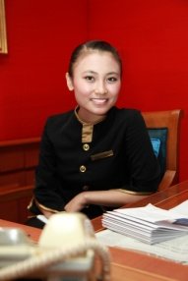
The tour brief
A tour brief is a document that allows the manager to define the tasks associated with a tour.
The brief informs the guide of all client, product and employer requirements associated with a specific tour.
In particular the brief provides a profile of the client group and includes all relevant tour documentation. The tour brief should contain all of the information that the tour guide needs to operate the tour. The tour brief is only used by the guide and is never given to clients on the tour.

Information provided in a tour brief
Naturally the amount of information tour guides need prior to running a tour can be quite extensive.
However the amount of detail actually provided in a tour brief can vary a lot and depends on the procedures of the company involved.
A more thorough brief may contain the following information.

- Duration of the tour
- Size and structure of the group
- Age range, socioeconomic background, cultural background, special interests, and special needs/requirements of the clients
- Specific itinerary requirements and tour inclusions( tour guide/ guide copy and clients copy)
- Special clients requirements or requests
- Key features of a tour or site
- Vouchers for all components, transport, accommodation etc.
- Airline tickets if relevant
- Passenger rooming list
- List of industry contacts involved in the tour
- Necessary report/ guide forms
- Company policy manual guideline.

Contracts

An essential aspect of confirming details of any forthcoming tour is to read any accompanying documentation. One of these vital documents is any tour contracts.
It is vital tour guides know the obligations on the organisation in relation to providing the tour.
This relates to understanding all the inclusions which have been agreed to, timing considerations (time of arrival, meal times, timing of activities, departure times), tour group member numbers, merchandise to be provided.

Tour Itinerary

The tour itinerary is the road map for any tour. The itinerary describes the traveller’s route and direction of travel. It lists travel arrangements in the date of order that they are taken, and often lists them day by day. All of the places visited by the traveller are included.
An itinerary is a list, or description of travel arrangements.
The itinerary is a document which lists all of the travel arrangements made for a passenger.

Tour guides will need to develop two itineraries.
One is given to the passengers who come on tour. Make this available to them before they arrive for the tour.
The other itinerary, often known as a running sheet, is just for the guide and includes any additional comments, notes, reminders or tasks that the guide has to complete to ensure the smooth operation of the tour.
This itinerary is included in the tour brief.
The itinerary describes the duration of the trip. Dates are in included in the itinerary, from the first day of arrangements to the last day. It also describes in sequence specific travel and tourism industry products used.
Some products commonly included in itineraries are:
- Domestic and international flights

- Transfers
- Rail and coach journeys, care hire and ferry journeys
- Accommodation of various types
- Any packaged tours
- Entry to attractions or events, e.g. sporting events, theatre
- Meals and sightseeing.

Identifying the group leader
Exactly who is the group leader can vary between the tour groups.
In some cases the Secretary of a club may be the ‘group leader’ or the coach captain who drives the group to the venue may be the ‘group leader’. Anyone who has assumed responsibility for organising a tour may be the ‘tour leader’.
The group leader may also be ‘the host’. That is, the person paying for the group visit. This could be an employer or an individual private person.
As a tour guide it is essential that each tour has a group leader. Having a group leader is a good thing and where possible one should be identified for every tour so that:
- Communications can be made through a central person – rather than having to communicate with multiple people, or unknown people

- Decisions can be more easily made – a group leader will have the authority to make decisions on behalf of the group and this will save having to negotiate with many different individuals
- Arrangement can be communicated to one person – and they can share them with the rest of their group. This makes it easier for tour guides to disseminate information to the group and makes it more likely all those who are to take the tour will receive the necessary information
- Presentations or site tours can be made to an individual rather than a whole group
- The venue has a contact point for informing the group of changes, following up payments, finalising last minute details, forwarding tickets or vouchers etc. to.

Confirming details of the tour

The details of a tour should be confirmed wherever possible in advance.
This means a week or several days before the tour takes place.
It means contacting the group leader and discussing the issues mentioned below.
This, of course, is not always possible and sometimes the only conformation is a brief meeting with the coach captain/ group leader when they arrive at the site or venue.
Sometimes ‘confirming’ has its correct definition meaning group leaders verify what tour guides have previously been told, and sometimes ‘confirming’ means obtaining fresh information for the first time.

Details to be confirmed
Details to be confirmed may include:
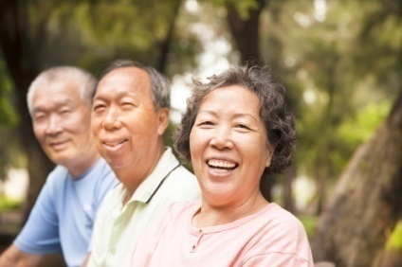
Group profile
This means identifying and confirming:
- Number of participants
- Type of group
- Origin
- Special needs or special requests
- Age
- Disabilities
- Language spoken.


Transport arrangements
This should address:
- Method of arrival at the site/venue
- Date and arrival time
- Parking arrangements for coaches and private vehicles – groups often have preferential parking
- Departure time
- Requirements for pick-up from hotels and transport to the site/venue.
Itinerary
The itinerary should always be checked to ensure the proposed tour will provide what is expected or what has been requested.
Standard practice is to email a draft itinerary to the group prior to the tour so they can confirm it or request changes.
Venues will strive to meet requirements of tour groups but it is a fact of life some cannot be met given that tours may also have to integrate with other ‘general public’ visits, comply with OHS requirements or accommodate other operational constraints of the site.

Making changes to the arrangements

Management and our guides should always try to accommodate changes to agreed arrangements required by the tour group.
This said, there may be a need to:
- Record all changes required – so there is certainty about what has been changed
- Notify others as necessary – where there are changes to numbers or meal requirements, then the catering department must be advised
- Advise group of additional charges – some alterations to agreed arrangements may necessitate the charging of extra fees or recouping of additional costs.

Being organised and well prepared

It is important for all staff in any job to be well organised. It is the role of tour guides to ensure they are prepared and ready to deliver tours.
For anyone who delivers tours, it is critical.
Planning is the central element of being organised and as they say ‘If tour guides fail to plan, tour guides plan to fail’.

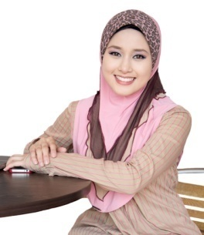
Allied to this is the concept of ‘first impressions’. When tour group members first meet tour guides they will immediately form an impression about them, the tour they are about to take and the site they are about to tour.
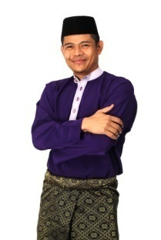
Tour group members expect team guides to be prepared and calm when they first meet them. They want and expect them to be ‘in control’. If they are not properly organised this will be instantly recognisable in their demeanour and this has the capacity to adversely impact on every other aspect of the tour.
A tour guide who is distracted when tour group members arrive, finalising last minute preparations, clarifying issues which should have already been addressed or trying to source information which should have previously been obtained does not inspire confidence!
It is essential that managers ensure tour guides are organised to enable them to:

Identify the upcoming tours they need to conduct.

They need to identify:
- Where the people are from
- When they are arriving
- What their needs, wants and preferences are
- What they have been promised and/or what they might be expecting.

Determine the things they need to plan and create for each of the upcoming tours
These may include:
- Developing activities
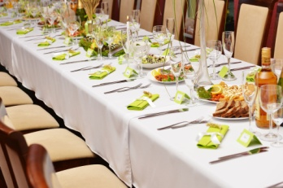
- Preparing handouts
- Selecting routes
- Checking sites
- Organising other staff to assist in supporting the tour – for things such as:
- Providing catering – meals or refreshments
- Conducting demonstrations
- Delivering specialist demonstrations and talks
- Supervising activities.

Project an image of professionalism, control and confidence
It is very unprofessional not to be prepared. It reflects poorly on them and the tour they are taking. It is a fact of life tour guides never recover from the start of a tour when they are disorganised.
Tour guides will be flustered and tour group members will notice this. They will always be playing ‘catch-up’ and they will be unable to focus on the things tour guides need to focus on.

Provide a positive visitor experience

Not being organised always leads to a poor guest experience. Tour members will:
- Sense the disorganisation
- feel disrespected by the lack of preparation and organisation
- Be less likely to recommend the tour to family and friends.
It must be central in the mind of tour guides when delivering a tour they have a primary objective of making this tour so spectacular that the people on it will recommend it to their friends and families.

While tour guides must, of course, be focussed on the current tour being delivering, they must also be aware of the need for this group to bring tour guides referral business.

Optimise safety for the people on the tour
Safety is often compromised where there is a lack of preparation and organisation if the tour guides’ mind is distracted by trying to recover the unplanned or disorganised scenario.

Ensure planning is complete
As part of the planning process it is essential that tour guides must:
- Dress properly – and look the part. Tour guides must wear a uniform if necessary and be properly groomed. Clothes must be clean and in good condition, well cared for and pressed. Clothes must reflect the needs of the tour
- Have prepared their commentary– so they are confident and comfortable with it

- Be at the appointed starting point for the tour well in advance – ideally tour guides should be there before any participant arrives
- Have organised all support materials necessary for the tour – such as handouts, costumes, materials, safety equipment
- Verify the muster point is ready – that it is clean, seats are available, DVD is set and ready to screen a corporate or site video or safety information
- Contact group leader– and confirm arrangements or capture last-minute details for the group
- Confirm the arrangements for the tour have been prepared and relevant staff are ready to receive the tour.


Prepare, print and practice commentary
Another important aspect of preparing for a tour is to prepare or revise a scripted commentary, and practice its delivery.
A scripted commentary should be thought of as a plan about what tour guides need to say on tour rather than a complete list of everything that will be said.

Preparing a commentary
As part of a tour guides’ role will usually be to deliver a pre-prepared commentary. This may be prepared by management or the tour guides themselves. Where no script exists tour guides may be required to prepare one.
Preparing a commentary is not a simple or easy exercise, and the following points should be understood:
Writing a commentary takes time
Tour guides cannot do it on-the-spot and rarely can they do it on-the-day it is required.
Writing a commentary can take weeks.
Understand all attraction information
Research and site knowledge are critical underpinning elements of every effective and engaging commentary:
- Research is required about what the visitors want, need or prefer to hear about.
- Research is essential about the venue where the tour will be delivered to obtain:

- Statistics
- History
- Details about the facilities
- interesting facts about the area or venue,
- Extensive facts about anything which is the main focus of the tour.
Check tour advertisements
Check the advertising undertaken by the tour agency, the site or the venue to identify topics promoted to guests and visitors and then ensure these are covered by the commentary.
It is also a good idea to do some on-the-job market research and speak to visitors at the site and ask them what they would want to hear about from a tour commentary.
Know the route
The commentary should describe and provide information about the venue in general but on what is visible on the tour itself.
This means tour guides must cover in some detail all buildings, natural and built attractions, events etc. as tour guides pass them.
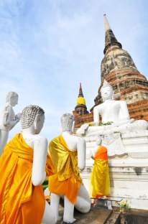
Involve others
The scripting process should involve others to:
- Contribute ideas
- Provide information, facts and figures
- Bounce ideas off
- Practice on.
Experience other commentaries
Tour guides should go and experience some other commentaries so they can learn from:

- What they do or say
- How they do and say it
- When they do and say things
- The amount of commentary they provide.

Key points of commentaries
- Avoid personal opinions, thoughts, beliefs and prejudices – a commentary is not the place to air personal views

- Avoid inappropriate language – such as:
- Swearing or bad language
- Racist terms
- Gender bias
- Politics
- Tour guides should prepare a draft – and then revise it time and time again until it has been polished to the required standard
- Tour guides must ‘speak’ the commentary when trialling it – tour guides can never get a proper feel of the commentary until it is spoken aloud. Simply reading it to themselves will not do it
- Tour guides have to read it out loud to others for their feedback. Tour guides should also record it so they can listen to it and self-critique

- Write the script from the guest/visitor perspective – for example if tour guides are at the front of a bus or tractor train and facing backwards towards the visitors, tour guides must identify landmarks from their viewpoint
- Use simple, plain language – this is not to infer tour guides should be condescending but highlights the need to keep things simple and easy to understand
- It is recommended tour guides use simple sentences, not long ones and use simple words and not complex ones

- The easier a commentary is for people to understand, the more they will enjoy it, the more they will learn from it, the more they will engage with the tour (and tour guides) and the more satisfaction they will get from the tour
- The commentary should reflect the nature of the tour – for example a tour focussing on nature may be expansive and emphasise awesome natural spectacle.

Produce hard copy of commentary

The best way to record commentary is by using cue cards. Cue cards are small cards which fit into the palm of tour guides’ hand. Tour guides can write headings and dot points on these cards to outline the main ideas of their commentary. That way, if tour guides do get stuck, they simply look at their cue card and it should jog tour their memory and allow them to continue. Tour guides can hold their cue cards throughout the commentary as long as they are not obvious to the group members.
A more thorough commentary document should be accessible either during or just prior to their tour commencing. This will provide tour guides with reassurance and security in the event that someone asks tour guides a question that tour guides do not know the answer to.

If the itinerary for a tour changes tour guides can quickly change the order of the cue cards or simply remove the appropriate cue card from their pile. The commentary doesn’t have to be altered because it still flows smoothly.
On each cue card have a heading referring to the site or attraction at the top and then have the dot points underneath the heading. Have one dot point for each key point that tour guides want to make in their commentary. Tour guides can include any references on the back of each cue card in case anyone requires further information. By using cue cards, tour guides can arrange their information however tour guides want to.
Tour guides may write dates and statistics in a different colour or font size to highlight this information. As tour guides glance down at their cue card, the colour will automatically catch their eye.

Cue card tips
- Headline and dot point form technique
- Information needs to be clearly set out on the front of the card

- Include the source of the information e.g. Book, person, video etc. on the back of the card
- Hold them and glance at them occasionally, or as often as tour guides need to
- Do not try to hide the fact that tour guides are using cue cards
- Number them so tour guides do not get them mixed up.


Practicing the commentary
Tour guides must practice any commentary they have to present.
It is never a good idea to present a commentary tour guides have never practiced because their delivery will lack confidence and conviction and fail to engage or inform the tour group members.
Practicing means:
- Reading it out aloud several times – not just once: five is a minimum
- Reading it in situ – this means walking/driving the tour route and commentating to align with points of interest and items mentioned in the commentary.
- Bringing the standard commentary to life with personal anecdotes or knowledge as appropriate to the venue, topics or interests of the group.

Check personal grooming and attire

First impressions are extremely important. As a representative of the organization the way that tour guides look and the way in which tour guides conduct tour themselves will reflect upon the host organization. It is important that the customers’ first impressions of tour guides are positive.
A customer will see their overall presentation as an indication of the quality of service they will receive during the tour.

Uniform and name badges
If tour guides are issued with a uniform, they must wear it according to the organisational requirements and that it is freshly laundered and ironed. Ensure that it is the right size so that it doesn’t impede movement and make tour guides feel uncomfortable.
Name badges help ensure their service is professional and personalized. By being aware of the tour guides’ name, customers will feel more comfortable with tour guides, and therefore have a better experience.

Personal appearance and hygiene
As a representative of the host organization, tour guides’ appearance is the first impression that customers get of the venue. Therefore, all staff need to be neat and tidy at all times.
- Shower regularly, clean teeth and use deodorant
- Keep hands and fingernails clean at all times
- All hair must be clean and neatly combed
- Footwear must be in good repair
- Open sores, cuts and wounds are to be covered with a dressing.


Personal well being
If tour guides feel have a disease that might be passed on to the customers, they must report the matter immediately. As a tourist guide, the very nature of their means that they will come into contact with many people over short periods of time. Tour guides may also be susceptible to picking up illnesses from their customers. It is best to stop contamination by recognizing symptoms early. The best way to maintain good health is to eat properly and get lots of sleep and exercise.

Organise information and materials

Preparation for tours generally requires tour guides to obtain appropriate materials and information specific to the tour to be delivered.
In many cases the information and materials will be generic in nature, and in some cases there will be a need to develop information and materials to suit specific tour group needs.

Steps in organising information and materials
It is very important to ensure, as part of this step, that:
- Sufficient items are obtained – there must be enough for the expected group numbers. Many people experienced in delivering tours will always include an extra ‘two or three’, just in case

- Information is current an accurate – be sure updates and amendments are made to information as necessary. It is totally unacceptable to distribute handouts containing incorrect, inaccurate or out-of-date information, facts or figures
- Printed materials are available in languages to suit the known language of the tour group. This may not be able to be actually done for every tour group but it should be a goal of the venue
- Certainly where the venue receives a large number of tourists speaking a particular foreign language, primary/important information should be developed in this language
- Information and materials address the identified objectives or themes for the group – so participants obtain maximum value-for-money, experience and satisfaction from their tour.

Types of information and materials

Depending on the type of tour or the venue tour guides may need to obtain information and materials to suit the needs and requirements of the tour schedule and activities.
Some of the common types of information and materials have been identified below.
Log book
This is a specific requirement for vehicles which are to be used for the tour. These are used to record driver name, dates and times of use, name of tour, odometer readings, accidents and requests for service.

Inspection checklists
This is used for vehicles to guide inspections to ensure all safety and other operational aspects of the vehicle are checked and verified. This includes things such as air conditioning, lights, public address system. They provide the basis for recording vehicle conditions and defects.
Support materials or props
These may be needed:
- As part of a costume
- To enable a demonstration or activity
- For presentation to tour group members for examination
- As examples of items relevant to an objective or theme
- For distribution to all participants to use or wear in order to fit into a theme.

Merchandise/give-aways
These may be provided by the venue as part of the package deal for the group tour.
These can range in type, value and quality from T-shirts and caps to colouring books and pens.
Tickets and vouchers
Where required by the inclusions which are part of the tour, guides may need to obtain:
- Meal and drink vouchers
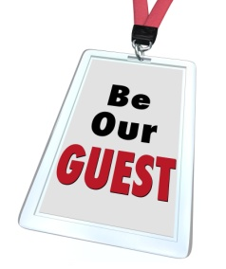
- Ride tickets
- Vouchers for redeeming at the retail outlets.
Name tags
This needs to be prepared for distribution to visitors on arrival. These may be pre-printed but are often written out on-the-spot when groups arrive.

Communication equipment
There are a number of communication equipment that needs to be collected and tested. These types of equipment will be explained in more detail later in this Learner Guide.
Personal protective equipment and clothing
This is required where visitors will participate in activities requiring same. Common options can include:

- Special footwear
- Headwear
- Gloves
- Eye protection, goggles and masks
- Special clothing.
Equipment

This is used to allow participants to engage in planned activities. Some of these may be distributed at the actual activity site, however sometimes they may be distributed as part of the initial formal briefing and safety advice.
Examples include sporting equipment, general utensils and items required for specific activities.
Brochures and site maps
These should relate to the site generally and contain advice about what to do or where to go if separated from the group.
Handouts

These contain:
- Specific information relevant to the objectives or themes and interests of the group
- Directions relating to activities planned for the group
- Safety information
- Quizzes, games and exercises for participants to complete.
A ‘We are here’ flag
Some venues equip their tour guides with a coloured flag easily seen from a distance to help tour group members identify where the group guide and other members of the tour group are located.
The wide range of items needing to be arranged prior to a tour underscores the need for those delivering tours to be properly organised.

Understand security policies and procedures
Every establishment will identify specific practices that relate to security. Some of these procedures arise from legal requirements, as well as common law concerns relating to ‘duty of care’, while other practices are grounded in more operational concerns such as protection of assets.
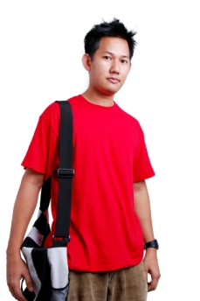
Like in any operation, security control procedures must be in place to ensure that not only key physical assets are strictly controlled and issued to appropriate persons in an appropriate manner.
An essential job for any organisation is for tour guides to implement security policies and procedures to ensure that property and asset security is maintained.
In essence, this means that tour guides must:
- Identify what the security policies and procedures are
- Ensure they understand the security policies and procedures
- Ensure they and tour members follow them.

Types of security policies and procedures
It is essential that all tour guides understand the various security policies and procedures that apply when planning, preparing and conducting tours.
Many tourism organisations will include security as part of their induction and orientation, but there are occasions where this is not the case and you will have to be pro-active in identifying what applies. This is especially true when conducting tours, when not only are you in different locations, but will be subject to various unpredictable scenarios and activities.
Whilst tour guides are encouraged to use their own initiative to resolve security issues, they are advised to contact management or seek out the Policies and Procedures manual which is usually readily available.
Security procedures for tours may have been developed and written to deal with the following sample of events and occasions:
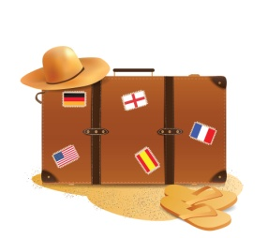
- Customers – this includes persons of tours
- Staff – this includes tour guides, drivers and other external suppliers
- Property – this includes assets belonging to the tour operator and personal belongings of both staff and customers of a tour
- Documentation and other records – identifying the records to be maintained, who is responsible for same, what the records are used for, who and where they must be forwarded to when completed
- Cash and non-cash transactions – including protocols for accepting payment and giving change, and the movement of cash as part of the tour, and to the bank
- Equipment – including marking of equipment, establishment of an Assets Register to record and track the movement of assets stored at a central location or issued as part of a tour and the procedures to be followed to optimise security of equipment from theft
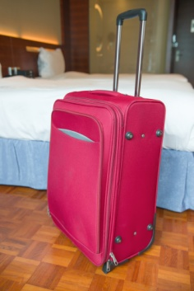
- Theft – detailing the response the tour guide will take when instances of theft by staff and customers are detected
- Emergency procedures and evacuations – including details of what the Emergency Management Plan contains in terms of responses to situations such as fire, explosion, medical condition, etc.
- Other events likely to endanger customers or staff – including responses to intoxicated or drug-affected customers, deranged people, angry customers and generally obnoxious and anti-social behaviour.

Types of assets

Whilst the types of assets will vary depending on the demands of specific tours, common assets that need to be controlled and managed include:
- Keys
- Security Passes
- Equipment.

Keys
There may be need for tour guides to obtain keys in order to gain access to certain areas listed on the itinerary.
Keys will usually need to be signed out, and signed back in.
Keys may be needed for:

- Doors
- Vehicles
- Displays
- Padlocks
- Gates
- Enclosures
- Emergency exits.

Security passes
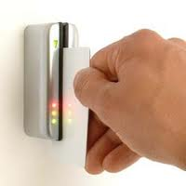
Security pass in some venues there can be a need for the person delivering the tour to apply for, and obtain, a security pass before being granted access to nominated areas.
In most venues the tour host has automatic access, subject to conditions at the times, unusual events or emergencies, to all parts of the venue.
A common courtesy is to ask the person in charge of the area for permission to enter or bring a group into the location.
On some tours every member of the tour group may be required to be provided with a security pass to enter nominated secure or sensitive locations.
Where security passes are required there is also a need to provide either a lanyard or some other way of attaching the pass to the visitor clothing.

Equipment
There are many types of equipment that need to be issued for use in a tour.
Some of the common pieces of equipment have been detailed.
Communication systems and items
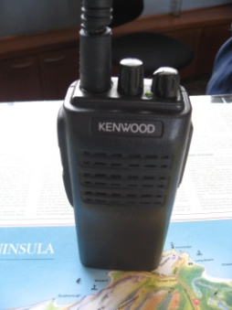
These include, but are not limited to:
- Microphones on PA systems
- Megaphones
- Walkie-talkies/two-way radios
- Cell phones
- Pagers
- Portable PA systems
- Laser light pointers.
Personal audio facilities
These are more commonly used for self-guided tours but can be used for certain portions of a longer tour. For example, the headset and player unit may be distributed to tour group members when they are given 90 minutes to wander at their leisure through the museum part of a larger site.
Audio-visual equipment

Where it is to be used for presentations:
- I-pads, phones, tablets, computer screens
- Data projectors and screen
- Overhead projectors and screen
- DVD players and monitor
- Movie projectors and screen.
Computers

This commonly refers to laptops, including internet connection, where this will form part of the tour or a component of a presentation or tour activity.
Activity items
This includes items required to enable tour group members to participate in scheduled activities. These will depend on the nature of the activity but possible equipment which may need to be checked can include:
- Ingredients people are going to use
- Utensils and items of hand-held or powered equipment.

Security of assets


There will always be a number of policies and procedures in relation to assets including:
- Restricting access – most establishments restrict the distribution of assets to their staff. Tour guides have fairly open access, while other staff members may have either limited, or no access. Generally speaking, access to assets is restricted to a ‘needs only’ basis
- Signing for assets– some establishments may have an asset register and staff who require specific assets have to sign them in and out
- Using safes and locked storage areas – each organisation must have a locked and secure location, both at the establishment itself and whilst on tour in which all assets are kept. This means the person with access to secure locations, often the tour guide when on tour, is in a position to allow or deny access to assets
- Policy forbidding the lending of assets – it is a standard operating procedure that staff are not allowed to lend any assets to anyone.

Check understanding and readiness of public address system
It is essential that tour guides understand:
- The different components of the public address system
- Ensure the system is ready for use
- How to use and control the system.

In-house systems
The basic in-house PA system is hard-wired into the venue and it is the tour guides’ job is to use the system as it has been installed and set up.
The basic components managers need to familiarise tour guides with are:
- The microphone
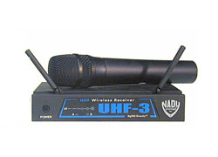
- Speakers – attention should be paid to identifying where the speakers are located so tour guides know where any public announcements will be heard
- Control buttons, switches or knobs.
In-house systems have limited controls tour guides need to learn about:
- Button to turn the microphone ‘on’ and ‘off’
- Volume control
- Buttons or switches to control the speakers to which the announcement will be sent.

Portable system
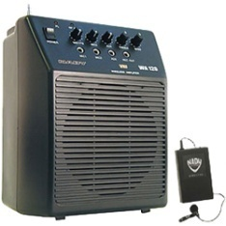
Portable PA systems are smaller, light-weight versions of the in-house system.
They may comprise speakers and speaker stands, microphones, a podium, and mixing capacity.
They may be powered by battery or electricity.
The component parts can be taken to locations within the venue.
Much modern portable equipment is ‘wireless’ meaning it is less cumbersome to set up, looks more attractive and is safer due to the absence of cords and cables.
Tour guides will need to know:
- How to turn the system ‘on’
- How to turn the microphone ‘on’ and ‘off’
- How to adjust the volume.

Megaphones
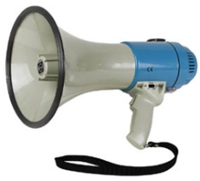
Megaphones remain a popular choice for communicating with groups of people in an outside location and on tour.
They are relatively inexpensive, simple to operate and effective.
Various options are available:
- Megaphone with hand strap
- Megaphone with separate microphone and shoulder strap
- Megaphone with pistol-style hand-grip.
Some manufacturers produce a ‘megaphone’ where a small speaker is worn on the shoulder, and the user talks into a microphone.
Tour guides will need to be able to:
- Turn them ‘on’
- Adjust the volume
- Use (or ‘key’) the microphone
- Adjust the shoulder strap.

Ensure equipment has been tested
Before tour guides set off to deliver a tour it is also essential they test the operation of all equipment tour guides intend using.
Important fundamentals when testing equipment
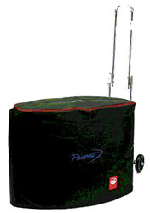
Three basic requirements about testing equipment before a tour are:
- Never ‘forget’ to do these checks – it is not acceptable and potentially actionable to conduct a tour without having undertaken the required tests and checks
- Take time doing the tests and inspections – they cannot be done properly if they are rushed. Allow sufficient time in planning to do them as required
- Make sure tour guides check, test and verify all the items, systems or equipment – it is never acceptable to miss checking items because they are running late, cannot be bothered, or because tour guides previously checked it.
Examples of tests
Basic tests must verify:
- It is present and available – this sounds basic but it is not unknown for other staff to borrow items for use elsewhere and to forget to return it
- All elements of the item are in place – a visual check should confirm nothing is missing from the item tour guides are checking
- It is safe to use – the safety checks will vary with the item but the following should apply:
- Always use common sense when evaluating safety

- Follow house checklists for checking items
- Visually inspect the items and use them
- Full operational capability – this can entail:
- Turning systems ‘on’ and trialling their key operating functions
- Checking battery levels
- Checking back-up systems
- Actually using the items, technology, system or item to verify it operates or performs as expected or as required
- Taking items out of their covers, pouches or holders and testing them
- Following internal inspection checklists to ensure no item is missed as part of the inspection process.

Checking all materials are present and ready
Tour guides will need to check to ensure all the materials and information that they will require for tours to successfully conduct the tour is present.
The materials or equipment that tour guides will need depends on the type of activity tour guides choose to conduct with their group.

Types of materials

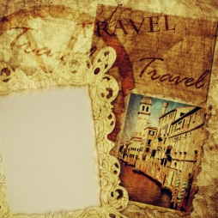
Materials and props need to be available. In bigger venues tour guides may need to book certain props in a central register to ensure they are available for the time tours are scheduled. Tour guides may need to develop a work sheet specifically for this group, or amend one that already exists.
Props, materials and aids might include:
- Work sheets
- Pens and pencils
- Binoculars
- Maps
- Photos
- Posters
- Torches (for night tours)
- Observation or activity sheets
- Plant samples
- Feathers, horns, antlers
- Blindfolds
- Diagrams
- Information leaflets
- Costumes
- Electronic guides.
Naturally each manager and each operation will have their own requirements for checking the readiness of all aspects of a tour before the tour actually starts.

1.2 Describe the legal implications involved in conducting guiding activities

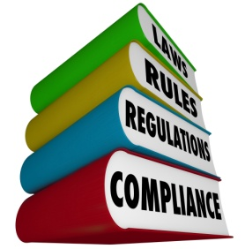
Introduction
Like in any business activity, a tour guide will need to follow and adhere to laws and regulations, at a minimum stated by the country in which the tour activities are taking place, enhanced by those stipulated by the organisation themselves.
In section 2.7 of this manual a number of enterprise policies and procedures will be discussed in more detail.

Corporate governance
The importance of good corporate governance has grown as governments, businesses and communities have become increasingly concerned about the ways in which businesses have been run.
Concerns have been underscored by numerous examples, most of which have gained significant media attention, of fraud, corporate collapses and general dodgy dealings.

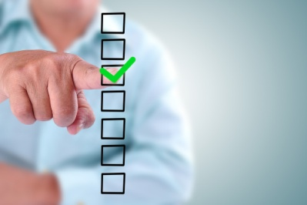
Need for good corporate governance
Primary reasons for the need for good corporate governance exist at micro and macro levels.
On a micro level, good corporate governance is needed to optimise the viability of individual businesses.
On a macro level good corporate governance is required to maintain the integrity of business, markets and the economy. This focuses on the critical need for people within a market (customers, suppliers, other businesses) to have faith in the fact that all operators are conducting their business in an ethical and compliant manner.
All we have to do is look at some overseas countries where there is little or no trust in their economies, where bribery and corruption appear rife and with whom there is little interest in forming a business relationship to see how important this need for effective corporate governance is.

Definition of corporate governance
Corporate governance is the system by which companies are directed and managed. It influences how the objectives of the company are set and achieved, how risk is monitored and assessed, and how performance is optimised.
Good corporate governance structures encourage companies to create value through entrepreneurism, innovation, development and exploration) and provide accountability and control systems commensurate with the risks involved.

Corporate governance responsibilities

Corporate governance responsibilities may include:
- Behaving in an ethical way at all times
- Ensuring that the interests of shareholders, other primary owners or stakeholders are paramount
- Ensuring that the interests of other stakeholders are also considered and given due weight
- Ensuring that the organisation’s financial position is clearly and accurately represented
- Ensuring that the resources of the organisation are used ethically and only for the purposes of the organisation
- Ensuring compliance with all applicable laws and statutes.

Areas of corporate governance
Traditionally, core principles of governance will apply to:
- Risk assessment and management

- Accountability
- Statutory and ethical responsibilities
- Reporting and performance monitoring
- Business plans
- Conflicts of interests.

Health and Safety
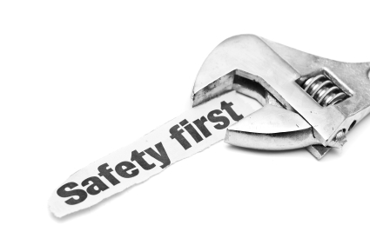
All businesses are subject to Occupational Health and Safety (OHS) legislation.
One of the tourist guides main concerns is the health and safety of their customers. You should be familiar with policies, procedures and standards which assist you in ensuring the well-being of your tour members.
These could include policies on weather, procedures on what to do if an accident occurs or Ministry of Labour laws regarding occupational health and safety.


Principles of health and safety protection
These principles include:
- To secure the health, safety and welfare of employees and other persons at work
- To eliminate, at the source, risks to the health, safety or welfare of employees and other persons at work
- To ensure that the health and safety of members of the public is not placed at risk
- To provide for the involvement of employees, employers, and organisations representing those persons, in the formulation and implementation of health, safety and welfare standards.

Health and safety legislation
Matters addressed within the legislation include:
- General duties relating to health and safety
- Duties of employers to consult with employees – including how that consultation is to take place
- Duties relating to incidents – such as the duty to notify of incidents and the duty to preserve incident sites
- Requirements in relation to licences, registrations and permits
- Representation of employees – including health and safety representatives, health and safety committees and the resolution of health and safety issues.

Duty of care
Legislation notwithstanding, tour companies and tour guides themselves owe a common law ‘duty of care’ to their customers.
Common law is law which is not the result of legislation.
It is law made by the decisions of judges over time. It is a set of rules developed by judges and these rules are based on ‘precedence’ meaning the judge must follow previous binding decisions when deciding a case.
If a judge does not follow precedence then the decision is not legally binding.
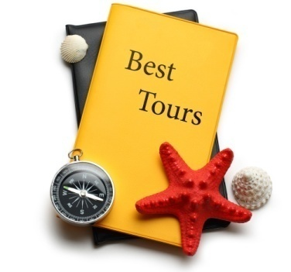
Common law looks at ‘fault’ and damages will be awarded based on the degree of fault, age of the victim and the extent of the pain and suffering.
Duty of care provisions require a business to take reasonable care to ensure that ‘foreseeable harm’ does not occur to people.
Where harm, injury or damage actually results from a business, including the actions of a staff member acting negligently (failing to exercise reasonable care to address foreseeable harm) and a link can be proven between the negligent act and the damage that resulted then the injured person can successfully sue for damages.

Employee Code of Conduct
Employees who work in the front line of an organization dealing with the customers directly, as a tourist guide, will often be required to adhere to a code of conduct.

This might include:
- Expectations on personal presentation
- Restrictions on the content of commentary
- Expectations about absenteeism or tardiness
- How to treat company property
- Conflicts of interest
- Personal behaviour i.e. Fighting or arguing
- Responsibilities regarding health and safety.

Fair trading legislation
Fair trading legislation places obligations on businesses to:
- Avoid misleading and deceptive contact

- Not to use unfair consumer contracts
- Avoid unconscionable conduct
- Issue receipts and itemised bills.
The legislation also makes provisions regarding:
- Implied contractual conditions involved in a sales transaction
- Refunds
- Advertising.

Ethical requirements
Ethical requirements relate to issues about which a personal judgement has to be made regarding the way either the tourism organisation or tour guides themselves elect to conduct its business.
In some cases, the ethical behaviour of a business may be governed by legislation. In other cases it is purely up to the individual operator to determine what is acceptable as ethical behaviour and what is not.
The basis of many ethical decisions comes down to personal values.
It is a fact of life that the economic imperatives of a business can often influence the ethical business decisions that are taken.
There are numerous topics that can be considered under ethical requirements ranging from specific actions to general operating protocols.

For example, ethically a tourism business is required to ensure attractions and venues visited benefit the customer and reflect what is advertised, instead of being selected based on commissions provided to the tour guide or organisation which negatively impacts on the customer experience.

Some ethical specifics
It is not the responsibility of this course to tell you what your personal approach to business ethics should be.
The limits of this course extend only to:

- Advising that you comply with all legislated requirements
- Recommending that you consider the total and end-result implications of all ethical decisions you take – many short-term benefits gained by virtue of taking an unethical decision can result in long-term loss
- Suggesting there needs to be an alignment between what your business stands for and the way in which it actually operates.

What aspects of business have an ethical component?
In short, nearly every aspect of operating a business has an ethical component.
When operating a business that is highly people-focussed (such as any hospitality business) this rises even more.
From an ethical perspective there exists a need for you to determine what your ethical standards, practices and platforms are in regard to:
- Products
- Service provision

- The environment
- People
- The community
- Tipping
- Discrimination against certain types of customers
- Money benefiting personal use
- Promotions and advertising
- Intellectual property
- Conflict of interests.

Risk management
Formal and structured risk assessment coupled with proactive and comprehensive risk management activities are becoming increasingly common in business.
A planned approach to risk management is necessary in business to:
- Demonstrate due diligence
- Protect the business from outside attack, loss or damage
- Limit exposure to civil and criminal legal action
- Establish plans to activate in the event that identified risk situations eventuate.

What is risk assessment and risk management?
Risk assessment involves:
- Identifying the risks
- Analysing the identified risk
- Evaluating the severity of the identified risk.
When the risk has been assessed, risk management should follow. Risk management seeks to reduce or eliminate identified risk by taking appropriate actions.

The procedures involved in risk management will vary depending on the nature and the scope of the identified risk and may include:
- Risk avoidance strategies
- Risk reduction strategies
- Risk retention strategies
- Risk transfer strategies.
These strategies are commonly reduced to writing and included in a formal enterprise Risk Management Plan.

1.3 Describe the characteristics of effective tour group leaders

Introduction
Naturally the role of a tour guide is extremely important as not only are they responsible for organising themselves and tour members in a transient and often foreign environment, but also to ensure that all logistics are arranged.

This section will explore some of the roles performed and characteristics required by tour guides.

Role of the tour guide
Being a tour guide requires you to discharge several different roles.
These can include:

Mediator
This is needed in order to:
- Mediate problems within the group or between individuals in the group
- Mediate issues between your tour and the place where the tour is being conducted. This may relate to issues such as timing of activities, access to exhibits, areas or duration of demonstrations.

Tour hosts are often required to be the ‘social lubricant’ between members of a group to handle disputes and facilitate individual engagement with the tour. High levels of social and interpersonal skills are essential for those who deliver tours.

Communicator
This involves:
- Delivering a commentary for the tour
- Responding to questions asked by tour group members
- Providing information
- Being a good communicator can also require you to interpret aspects of the tour (such as culture and customs, history, the environment, social factors and the economy).

Manager
There is a need to manage the tour group members so the schedule of the tour is adhered to, no-one gets lost, behaviour is acceptable and all participants get maximum value from the tour.
There can also be a need to issue tickets, badges, equipment, handouts and other group specific or tour-specific items.
Inherent in this management role is the need to ‘lead’ the tour by directing (as appropriate) where people go, what they do, how long they spend in an area/on an activity.
This may also require the tour host to show people what to do, demonstrate skills, etc.

Teacher
All tours contain an element of teaching people something or facilitating their learning.
This means the tour host has to have extensive knowledge of the topic or area which is the focus of the tour, and they must also have extensive knowledge of the wider area in order to be an ambassador for the country.

OHS representative
Delivering a tour can require you to:

- Explain safety requirements – telling people what they should and should not do to remain safe
- Distribute safety equipment – and demonstrate how to wear or use it, as well as assisting people to get into protective clothing
- Observing and monitoring tour group members to ensure they do not get injured or place themselves or others in danger
- Taking appropriate action when danger threatens or an emergency situation occurs – or when a person is injured.

Sales person
The person delivering a tour can be required to:
- Promote retail opportunities available within the tour to optimise sales
- Encourage referral business – from families and friends
- Generate repeat business – where participants come back for another tour
- Advertise any aspect of the business or site as determined or required by management.

Characteristics of effective tour group leaders
Characteristics of effective tour group leaders may include:
- Ability to be proactive
- Being an effective communicator
- Respect for others

- Confidence
- Enthusiasm
- Fairness and consistency
- Open-mindedness
- Knowledgeable, skilful and competent
- Organisational ability
- Initiative
- Ability to direct and delegate.

Work Projects
It is a requirement of this Unit you complete Work Projects as advised by your Trainer. You must submit documentation, suitable evidence or other relevant proof of completion of the project to your Trainer by the agreed date.
PROJECT - CONDUCTING A TOUR
You are to select a tour of your choice. This 'tour' will be the focus for all work projects in this manual.
1.1 Provide a summary of your tour:
Please provide information relating to the following aspects of the tour:
- Type of tour
- Tour duration
- Tour schedule or itinerary
- Locations visited as part of tour
- Tour attractions
- Target market audience.
1.1 Plan for your tour:
An integral part of conducting a tour is to undertake preparation activity before the tour can take place.
Please undertake or explain the practical planning activities that you would undertake as part of the planning process based on the following points:
- Identifying company policies and procedures
- Preparing a tour itinerary
- Prepare, print and practice commentary
- Check personal grooming and attire
- Organise information and materials
- Checking all materials are present and ready.
1.2 Describe the legal implications involved in conducting guiding activities:
- Identify legal implications that influence a tour
1.3 Describe the characteristics of effective tour group leaders:
- Explain the role of the tour guide
- Identify characteristics of effective tour group leaders.

Summary

Identify the pre-requisites for responsible tour leadership
Describe host enterprise policies and procedures relating to tour guiding and tour activities
- Company policies and procedures
- Identifying upcoming tours
- The tour brief
- Contracts
- Tour Itinerary
- Identifying the group leader
- Confirming details of the tour
- Making changes to the arrangements
- Being organised and well prepared
- Ensure planning is complete
- Prepare, print and practice commentary
- Check personal grooming and attire
- Organise information and materials
- Understand security policies and procedures
- Types of assets
- Check understanding and readiness of public address system
- Checking all materials are present and ready.
Describe the legal implications involved in conducting guiding activities
- Corporate governance
- Health and Safety
- Duty of care
- Employee Code of Conduct
- Fair trading legislation
- Ethical requirements
- Risk management.
Describe the characteristics of effective tour group leaders
- Role of the tour guide
- Characteristics of effective tour group leaders.

Element 2:
Co-ordinate tour group movements and activities

2.1 Advise tour group members of the type of tour and the proposed movements and activities

Introduction

In the previous section, the focus was on getting ready for the tour.
This section will focus on the activities associated with conducting and leading the actual tour.
As can be expected, there are many activities to be performed by tour guides.
Regardless of the activities to be performed, the focus must always remain on the tour and the tour members.
Before we look at the activities to be performed, it is important to understand the different types of tour members and tours themselves that may be conducted.

Types of tour group members
Tour group members can be anyone, from anywhere.
Participants can be domestic residents or from anywhere around the world.

They can be of any age.
Tour group members may include:
- Domestic and international people
- Males and females
- People from different age groups
- Special interest groups
- Special needs customers
- Open groups, i.e., groups comprising an unpredictable mix of the general public
- Homogenous target market groups as defined by various demographic characteristics.

Many tour members have specialised interests such as:
- History

- Flora and fauna
- Natural attractions
- Action experiences
- Shopping
- General interest.
The size of tour groups also varies depending on the nature of the tour but it is generally understood it is difficult to connect with, monitor, organise and supervise a group of more than 20.

Types of tours
Tours can be delivered:
- On-site - at a park, garden, tourist attraction or natural site
- ‘Elsewhere’ - such as tours of the city, tours of an area, or tours of a business or property in a remote location.
Tour lengths can vary from very short (1 - 2 hours) to half-day, full-day and several day tours.
Tours will vary by type and duration and may include:
- Half and full day tours
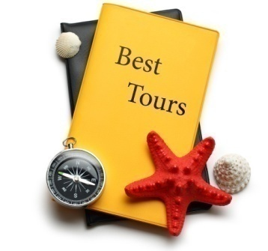
- Extended tours
- City, rural and remote area tours
- Cultural and eco-tours
- Adventure and recreational tours
- Special interest tours
- Walking tours
- Four-wheel drive tours
- Boating, aerial and cruise tours.

Getting ready to greet participants
To give tour participants a positive and welcoming greeting tour guides must:

Be prepared
This means:
- All the organisation for the tour must have been totally completed
- All materials ready for distribution have been obtained and assembled
- All relevant details about the group should have been obtained and studied so tour guides are fully aware about tour group profile, needs, arrangements.


Be there
It is essential tour guides are there before the promised starting time:
- This means being at the pre-determined point 10 – 15 minutes early
- This lets participants know they were expected and preparations for their arrival/
- attendance have been taken
- This inspires confidence in tour guides and enhances their credibility right from the word ‘Go’.

Greeting of participants
Before embarking on a tour, it is important that you meet and greet your customers.
Customers like to be met with a friendly face and a smile so make sure that you let your customers know that you are pleased to see them and that you are an approachable and friendly person.
Your aim should be to make your customers feel comfortable with you and with the other customers in the group. You want them to feel welcome and know that you are available to answer any questions.
At the same time your customers will be getting to know you, and assessing your capabilities, attitudes and personality. Use the time to establish your credibility, to create a warm and friendly atmosphere, to put customers at ease, and to set the scene for an enjoyable time.
During this period you might check customers against a passenger or booking sheet to ensure that all the customers who have booked are present. You might also need to follow up on any missing persons.
You should also check the following:
- Are customers on the right tour?
- Have they undertaken all the necessary requirements?
- Do they know that they are leaving and not returning for a few hours?
- Have they made the necessary arrangements and toilet stops?
- Are they wearing the appropriate clothing?
- Are they carrying the appropriate gear?

- Are there any alarm bells with regard to medical conditions?
- What about potentially challenging individuals who were dragged along to the activity by their parents or by their spouse?
- Is anyone in the group beginning to express concerns, special interests or challenging expectations?
Find out whether there are any knowledgeable customers within the group who might be able to share their expertise at relevant points during the tour.
It is also an opportunity to listen to the ‘language’ of the group, and their level of understanding of the concepts and ideas you will be exploring and discussing. Bring a couple of terms into your conversation and assess customer’s responses. Do they already know the terms? Do they ask you for an explanation? What is their topic of conversation?
It might be at this point that you need to speak to a customer if they are not properly attired. For example, if you are taking a hiking trip through a remote area and someone turns up wearing sandals then it would be advisable to talk to that person and assess whether he or she has other footwear. Any personal issues involving individuals, such as inappropriate footwear, is best undertaken on a one-to-one basis. And if you do refuse someone from a tour, give your reason.
Encourage customers to meet each other. For lengthy tours you might introduce a few ice-breaker activities to encourage a social interaction between group members before the tour gets under way.
It is an opportunity for both yourself and the customer to confirm necessary logistical information about the tour, and to consider the capabilities of your group.

Welcome customers
It is here that you gather your customers together and welcome them as a group. It is important that you start on time, even if you are still waiting for latecomers.
Let customer know what’s going on. For example, ‘Hi everyone, it’s 9 am which is the start time for our tour. We are still waiting on a few customers, so I hope you will be okay if we wait another five minutes before getting under way.’ This way, you have acknowledged those customers who did arrive on time.
The practice of timeliness is even more important with extended tours as you need to establish the habit early that being on time means being on time, and when you say be back at the coach by 2 pm that you mean 2 pm. If you are lax with your times, customers will develop a corresponding habit of being lax as well.
As part of the welcome presentation, mention your name and also that of any other persons who might be working with you on the tour. While you might have introduced yourself to individuals it is best to confirm it with the whole group.
This way, your customers know exactly what to expect from the tour, when each event will take place and when they have to back at the meeting point. This is especially important when running tours that run for a day or longer.
You need to ensure that your customers are fully aware of what is going on for the rest of the day. You will need to provide more specific details as the events get closer. But an overview is a good starting point.
If it is relevant or appropriate you may include the following information:

Giving introduction of tour
Group tours should always commence with a brief introduction.

Tour guides’ introduction should:
- Introduce yourself to the group. Give a very brief background of yourself, for example ‘I’ve been working in this museum for five years and over that time have worked with quite a lot of the displays. Today I will be taking you to what I believe to be some of the unique and more fascinating displays’
- Identify the site/venue or tour area. State your location, for example ‘Welcome to .............’
- Name the group as part of the talk
- Provide orientation details such as services and facilities
- Some meeting points might have several tours departing at the same time, so it is best to check that customers are on the right tour

- Identify any ground rules customers might need to observe; try as much as possible to stay in the positive by telling customers what you want them to do rather that not to do
- If you are working on a site with specific ground rules, these will need to be provided to your group
- Introduce any co-workers who will be part of the tour – this may include:
- Assistant tour host
- Vehicle driver
- Interpreter
- Demonstrator
- Guest speaker
- Include a Q & A session – so participants have an opportunity to:
- Find answers to pressing issues before the tour starts
- Address anxiety
- Clarify issues and arrangements
- Follow internal organisational policies and procedures – which may involve:
- Head count for the tour group – ‘pax’

- Signing/completing internal paperwork
- Completing specific tour manifest
- Screening site or venue video
- If it is a car-based activity remind customer to check that their cars are locked and valuables are left out of sight.
This period of your tour is primarily concerned with welcoming customers and providing the relevant logistical information. It is about bringing individuals together as a group, rounding them up so they are ready for the tour, and setting the mood and tone of the tour.
As a guide, you are responsible for coordinating your tour group’s movements. Therefore, at the beginning of the tour, it is important that customers are briefed on practical tour issues so they know what to expect and what is expected of them.

Explain the tour itinerary
You need to let your customers know what the tour itinerary is before you set out on the tour.
You may want to give each customer a photocopied itinerary and then go through it with them verbally. The tour itinerary should include:
- Explaining the itinerary
- Explain the type of tour they are taking:
- Naming the tour
- Identify the duration of the tour
- Give the length of the tour in distance
- Outline how long the activity will take and when you are due back
- Explain the route they will be taking and any difficult sections, and make sure they have the necessary gear and equipment
- Up-dating tour group members regarding schedules and changes to the itinerary
- Explaining reasons for changes to the itinerary
- Providing verbal and printed information
- Conducting demonstrations
- Sharing personal experiences
- Provide an overview of what the tour will cover – as appropriate this may include mention of:
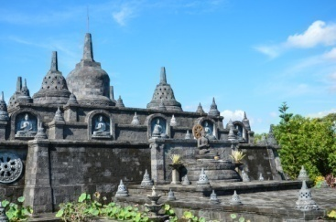
- Points of interest and highlights
- Special events which have been organised for the specific group
- Unique features on this tour
- Demonstrations and activities
- Displays and shows
- Meals and refreshments
- Free time
- Photo opportunities.
One important part of providing information is ensuring instructions are understood.

Procedures at tour stops and time spent at each stop
It is important to relay all information to customers about tour stops and times. It is good to do this at the start so everyone understands what is expected. Customers need to know what is happening to them. If customers are unaware of what is happening, you are not managing the tour group very well. It is your responsibility to advise customers on all tour procedure.

For each tour stop you should advise customers on the:
- Availability of toilets
- Availability of refreshments
- How much time they have at the site
- Specialist shops.

Health and safety procedures
As a tour guide, you are responsible for the safety of your customers:
- It is important that you relay all information about health and safety procedures as soon as possible. This would involve things such as:
- ‘Don’t drink any tap water, only drink bottled water’
- ‘While the coach is in motion, everyone please remain seated. This is for your own safety.’
- ‘The area is well known for pick-pockets. Hold onto your handbag and don’t wave your wallet around. Just be careful and aware at all times.’
When you are explaining safety rules, it is important to give the necessary information without scaring customers. Be factual, calm and in control and you will give the tour group confidence.

Local regulations
You, as a guide, need to take into consideration the comfort of not only the customer on your tour, but the customer in the community you are touring in. They live and work in the area every day and you must explain this to your tour group. You should establish some ground rules from the start to ensure that the host community is treated with respect and any rules and regulations are adhered to.
You should let your tour group know about:
- Noise control
- Prohibited areas
- Rubbish regulations
- Alcohol consumption.

Group rules and regulations
Group rules are all of the things you are asking your customers to do in a particular area or throughout the day.
It is very important to explain group rules and regulations. A very common group rule is to keep together. You don’t want customers wandering all around the main street during a walking tour. You need to keep everyone together.

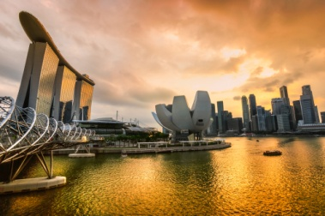
Specific site procedures
It is important that customers are aware of any specific site procedures for example they may have to stick to the paths at an historic site.

Cultural considerations
If your tour involves visiting a place where customers from different cultural groups live, customers need to be made aware of the cultural differences. You will also need to explain that they will need to be considerate to these differences. You may even want to explain how they can show consideration and respect.
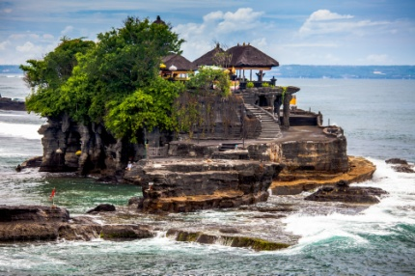
It is important to inform customers about special customs and codes of behaviour so they don’t offend the local customer. Relevant customs or codes of behaviour may include the appropriate dress code for visiting an area. In this case it is your responsibility to advise customers that the local customer are offended by certain styles of dress.

Environmental considerations
You also need to make your customers aware of environmental considerations. As a tour guide, you need to ensure that your tour group makes minimum disruption and disturbance to the environment they are visiting.

2.2 Maintain adherence to the tour itinerary to the greatest extent possible

Introduction

As the tour guide you must follow the itinerary exactly. You must be aware of everything that is listed on the tour itinerary. When a customer receives their tour itinerary they are expecting and looking forward to seeing the sites listed on the itinerary.
It is your responsibility to ensure that you fulfil those expectations. You can’t just change a tour itinerary to suit yourself. The only time a site or attraction may be missed is when unforeseen circumstances arise that can’t be predicted or prevented, such as sudden heavy rain.
To ensure that you maintain the tour schedule it is essential that you stress the importance of timelines. If you are lax with your times, the visitors will not take your request seriously and therefore the whole tour may be affected. Your strength as a leader will help you manage the group in such a way that timelines and schedules are maintained.
Remember that the more people you have in the tour, the longer it will take to do things.

Maintain adherence to the tour itinerary
Maintain adherence to the tour itinerary may include:
- Monitoring times to maximise the chance of staying on schedule
- Adjusting destinations and activities on the basis of events arising and time blow-outs
- Modifying allocated timelines on the basis of events arising and time blow-outs
- Liaising with staff, tour group members and providers to vary the itinerary, as necessary
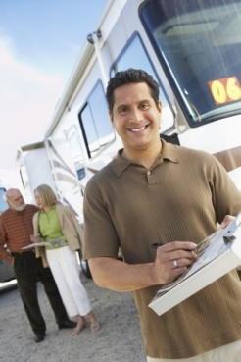
- Applying effective communication and negotiation skills to provide the basis for regaining the scheduled itinerary.

Changing the itinerary
There are times when a tour itinerary can be changed slightly. This does not mean skipping any attractions, but rather including additional attractions if you are ahead of your time schedule.
When on a tour, you may find that things happen that you didn’t expect to happen including:
- Systems failure
- Technical or equipment failure
- Injury or accident
- Adverse weather conditions
- Inappropriate customer behaviour
- Sudden closures
- Change of access.
However these unexpected things happen or services are cancelled or there are unavoidable delays you are forced to change the itinerary. For example, if you arrive at a site and it is closed due to bad weather you will have to change the itinerary.

Need for a contingency plan
You must always have a contingency plan. A contingency plan is a plan for alternative activities if something unexpected happens. It is your responsibility to organize the alternative activity promptly and efficiently.
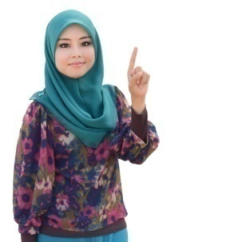
Then courteously and sensitively inform customers about the enforced changes or deviations in the itinerary.
It is also necessary to advise suppliers and other colleagues who may be affected by the changes.
All of the changes in the tour itinerary need to be done with a minimum of disruption to customers. Customers need to be aware of any problems, but they don’t need to be involved in fixing them. It is important that you keep your customers informed of your progress in fixing the situation, as they will be concerned about it too as it is affecting them.
When faced with an unexpected event, it is important that you are aware of sources of assistance that you may be able to use. You need to be able to quickly think of them and most importantly, to be able to quickly access them.

2.3 Provide tour-related advice and information to the tour group members

Introduction
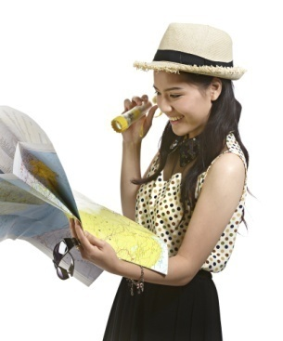
Given that customers may considerable money to be part of a tour, they expert to experience venues, receiving the greatest possible benefit from the experience.
This includes:
- Having a smooth visit
- Visiting all necessary sights
- Not getting lost or delayed
- Receiving accurate and informative information
- Being given helpful information or materials to help enhance the experience.
Therefore it is essential that tour guides:
- Have a thorough understanding of venue sites
- Ensure customers receive all necessary materials and information
- Ensure the experience is a positive one.

Familiarise self with locations
Attention has already been drawn to the fact those who deliver tours need to have excellent levels of knowledge about the tour (topics, highlights, sights, attractions and facts and figures) they will be conducting.
This raises the need for those who deliver tours to also have a comprehensive knowledge of the site, venue or area where they are conducting their tours.

Examples of things to find out about
Depending on what is available at your site/location, there is a need to learn about the following so information can be passed on to tour group members:
- Toilets/washrooms – male and female

- Disabled facilities – which may include:
- Toilets
- Ramp/wheelchair access
- Disabled facilities such as wheelchair hire/loan
- Viewing areas or platforms
- Baby change facilities
- Lost and Found facility
- First aid station
- Management and administration offices
- Standard exit point from the venue

- Emergency exits
- Evacuation assemble point
- Car parking areas
- Public transport points – such as bus pick-up points, taxi ranks
- Rest areas, including sheltered or air conditioned areas
- Eating or cooking facilities
- Drinking water
- Emergency equipment – fire extinguishers, hose reels, alarms, lifebuoys, first aid kits
- Vehicle-specific facilities – such air conditioning, televisions, on-board lavatories, drinks, towels
- Retail outlets – for meals, drinks, snacks, memorabilia and souvenirs, photographs, locations for redemption of tokens, vouchers or coupons
- Any other facility advertised or available as appropriate to individual sites, venues or attractions.

How to identify these facilities
You must be able to advise tour group members of the location of all the facilities available on tour.

To do this you can:
- Go on a tour at your venue that is conducted by another tour host
- Speak to other staff about what is available – most venues have lists about things such as locations of communication systems, alarms, fire fighting equipment, keys
- Walk around the venue – and be alert to noting the location of all facilities
- Read a map of the venue – to become familiar with what is available: be able to interpret
- the legend which identifies the location of various facilities.

Need to know this
You must be able to advise tour group members of the facilities available and how to access to them in order to:
- Generate credibility as a tour leader
- Give you confidence you can respond effectively to questions posed
- Optimise tour group member satisfaction
- Promote sales
- Protect safety and security of people.

Importance of non-verbal and verbal communication skills
It is vital you understand communication is a two-way process.
You have not effectively ‘communicated’ with a tour group member until you have received verbal or non-verbal feedback from them indicating they have received and understood the message you have sent them.
Simply telling someone or a group something cannot be seen as communication because this is only a one-way (from you to them) message.

Non-verbal skills
Non-verbal skills relate to the body language used when communicating with tour group members.
It refers to the way you use and hold yourself/your body, your facial expressions and the speed at which you walk and talk.
In your role of delivering tours it is to be expected your non-verbal skills should:
- Use open body language – open arms instead of crossed arm, facing people rather than being side-on, open hands rather than clenched fists or making eye contact
- Be positive rather than negative – so be alert to the fact the following all send negative messages:
- Sighing

- Slumped shoulders
- Looking around anxiously
- Drumming fingers on a table, desk or other object
- Eyes rolled backwards
- Understand many people will see you when they cannot hear you – so what they see needs to be appropriate and positive. You need to realise you are always on public show/people are always looking at you so the way you look is vital.
- Positive messages can be sent by:
- Standing upright
- Direct eye contact
- Leaning slightly forward
- Smiling
- Match the needs of the group – this may mean walking slower with seniors, and talking more slowly with those from another country or for those who do not have English as their native tongue.
You must also be alert to these signals from tour group members as they are primary indicators the person is not happy, is not enjoying their experience.

Verbal communication skills
When talking to tour group members, tips for effective communication include:
- Use simple words, phrases and sentence structure
- Do not use words or terms the participant is unlikely to know the meaning of
- Think before you speak – be sure of what you want to say and how you intend saying it
- Avoid using a raised voice – unless there are noisy barriers to communication, if there is danger or emergency situation
- Never swear or use rude, offensive or suggestive language

- Be respectful of and sensitive to all people – their nationality, their disabilities, their age, their gender
- Use pitch, tone, voice quality and projection as appropriate for each situation
- Do not mumble
- Do not cover your mouth when talking – unless this is necessary when using a microphone etc.
- Try to face the person you are talking to
- Provide extra information or clarification on the basis of feedback received
- Use a communication style suited to the nature of the listeners – what is appropriate for senior citizens may not be suitable for young people
- Keep conversations, discussions, advice and responses to questions at the same tone set at the start of the tour – be consistent. Changing your attitude and tone can confuse participants and lead them to believe something is wrong or they have done or said something wrong.

Interpersonal skills
The following skills are important for effective communication:
- Face the person you are talking with – this helps show you are paying attention and allows the both of you full access to the non-verbal communication underpinning the spoken word

- Maintain eye contact if possible – this tells the other person you are paying attention and lets them know you are still tuned in
- Keep a good posture – posture is part of body language and it is important you do not give off the wrong signals such as ‘I’m bored’, ‘I’m in a hurry’, or ‘I wish they’d stop asking questions’
- Address a person by their name, if appropriate – it is said the sound of one’s own name is one of the sweetest sounds we can hear. Using a person’s name also displays respect and indicates they are not just a number

- Listen carefully – employ ‘active’ listening skills including asking of questions (“Did you understand that?”, or “Has that answered your question?”), paraphrasing what the other person has said and ensuring your body language shows you are paying attention
- Ask questions within the topic of conversation – this demonstrates your interest in what they are talking or asking questions about: for example “Have you been to other zoos before?”, “Have you seen these elsewhere?”, ”Which ones do you like best?”
- Maintain a social distance – when talking to a person don’t crowd them or intrude into their space. Respect their position physically and allow them their own space.

Need for alignment between verbal and non-verbal language
It is important when communicating with people that your body language reflects your verbal language.
Where there is a mismatch between the messages your body language is sending and the messages your verbal language is sending, people will be confused.
Generally speaking, they will tend to believe your body language as people generally believe this is the most truthful form of communication.

Using basic communication to deliver commentary
The commentary on a tour must be communicated to the participants.


Basic communication strategies
Basic communication strategies which should be used to deliver commentaries may include:
- Ensuring tour guides are visible to all participants
- Face the group
- Speaking loudly enough for everyone to hear
- Using technology to help project their voice
- Remaining enthusiastic and appropriate for the tour content and as appropriate to the nature of the tour group members
- Beginning the verbal commentary sufficiently in advance of a scheduled tour stop

- Alternatively tour guides may elect to arrive at the stop, and then deliver all the commentary at this point
- Focussing attention on entire group
- Communicating at level that will be understood by the audience considering their age, education, language, culture and special needs
- Seeking feedback from the group throughout the commentary:
- Encouraging questions
- Making the commentary a ‘unique’ event
- Knowing when to be quiet.

Communication techniques
In relation to delivering a commentary the following are useful communication techniques:
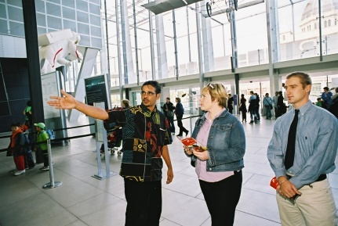
- Repeating parts of the commentary
- Paraphrasing when there is a lack of understanding
- Speaking at a different pace
- Using plenty of pointing and hand gestures
- Involving the group
- Being constantly alert to barriers to communications
- Checking for understanding of what tour guides have said
- Increasing the volume of PA and communication technologies
- Using extra staff
- Practice with whatever technology tour guides intend using to aid communication.

Deliver your commentary
Customers are attracted to guides who are relaxed, confident and interesting when delivering their commentary.
Remember these Do’s and Don’ts when delivering your commentary:
- Do use appropriate language in your commentaries to meet your customers’ needs

- Do use correct grammar
- Do use vocabulary that your customers can understand
- Do use anecdotes help to personalize your commentary
- Don’t swing your arms around during your presentation because it is very distracting for customers
- Do use hand gestures to clearly identify points of interest to your customers.
- Do smile
- Do maintain eye contact with customers throughout your commentary
- Don’t use annoying or distracting habits
- Do maintain a certain amount of space between yourself and your customers
- Do speak clearly, slowly and precisely
- Do maintain a comfortable vocal pitch for your customers during your commentary
- Do speak at a speed which is appropriate for your customers.
- Do adjust the volume of your voice to suit the number of customers and the space around you
- Do use appropriate vocal variations and non-verbal expressions.
Remember, customers do not just want a commentary where they only receive information from you. They want to be involved in the commentary. Give customers ideas and activities to try between tourist stops. For example, ask them to observe and compare the different architectural styles of the buildings in your city on a half day city tour. You can then use their observations for an interactive discussion at the next building you visit. You have encouraged customers to become aware of the relationships between buildings visited during the tour and also stimulated them by engaging their senses.
Another way of ensuring that your commentary is a success is by encouraging your customers to participate. You should also let your customers know that they are free to ask questions.
Customers will usually want to ask questions throughout the commentary. They may want to clarify a point or they may want to know more details. However, you need to make sure that your customers don’t interrupt the flow of the commentary by continuously asking questions.
Remember to also provide opportunities for customer to be alone with their own experiences.
You should also utilise the unexpected and spontaneous occurrences on the tour. If possible weave them into the theme and story of your tour.
Be aware of opportunities to present information on the same subject but from differing aspects.
Mix up the activities and content being delivered within the commentary. Work with stories, bring along props, tell anecdotes and share stories.

Provide tour-related advice and information
This must include consideration of the most effective way to deliver this information based on the needs and profile of the group and may relate to:
- Describing and explaining itinerary information
- Describing and explaining carrier, supplier, venue and activity provider information
- Issuing vouchers and tickets
- Supplying contact details for tour leader and tour staff
- Explaining procedures if tour group members become separated from the group
- Providing promotional materials.

Provide information on local attractions and activities
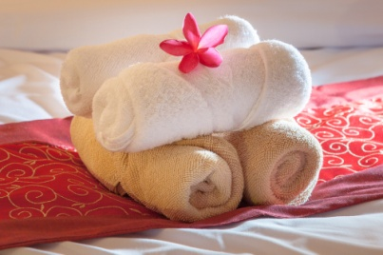
When on a tour, especially longer tours, your customers will be given free time in between activities where they can fill in their time as they wish. You should give them information on:
- Good shopping areas
- Food and clothing markets
- Recreational facilities
- Other short tours operating in the area
- Restaurants
- Theatres
- Hairdressers and beauticians
- Religious services.
This would include where they can find these things and how they can get there. You may even want to provide them with a map of the area.

Consider audience learning styles
Many tours are learning experiences for the tour group members. To optimise their learning it is useful to know something about learning styles and how the learning styles if individuals impacts on their actual learning and their experience and satisfaction with the tour.
The theory of learning styles states:
- People have their own preferred learning styles
- The closer their experience involves their preferred learning styles, the more they will learn and the better they will enjoy the experience.

This means the closer your tour presentations, activities and commentary align with a person’s learning style, the more they will appreciate it.
It also means it is impossible to cater for everyone’s unique blend of learning styles or preferences!
Learning styles include:
- Visual – this is where people learn best by seeing, viewing, observing, looking at things (DVDs, activities, objects) and watching
- Auditory – this is where learning is optimised through listening and hearing what is being said, sounds, noises, stories and commentary
- Written – where people learn from handouts, written material, signs
- Kinesthetic – where they learn best from doing things, a hands-on approach, from participating and doing things for themselves.
In reality most people have a blend of preferred learning styles, referred to as multi-modal, meaning they learner best when a combination of two or more of their preferred learning styles are engaged as part of the learning process.

For tour guides who have prior knowledge about a tour group they may be able to accommodate learning style preferences, or there may be insufficient time or resources to do so.
A critical need to accommodate learning styles occurs when, for example, a group is expected who have disabilities necessitating the development of a tour taking these needs into account.
For example, if delivering a tour to hearing impaired people then the primary ‘auditory’ option of delivering a verbal commentary cannot be relied on.
Likewise if the group is vision impaired the commentary may need to be altered to sensitively remove references to ‘seeing the animals’, ‘watching the activity’ or ‘drinking in the view’.

2.4 Supervise movement and activities of the tour group

Introduction
Given that tour groups will compromise a large number of people, each with different interests at attractions, pace of walking and individual needs such as food, drinks and toilet breaks, it is not uncommon for tour members to go in different ways, separate from the group or to get lost.
The control of people movement is essential to not only ensure people do not get lost, but delays in movement between and to the next attraction are kept to a minimum.

Supervise movement and activities

This may include:
- Providing advance warning and information of up-coming activities and destinations
- Directing tour group members to locations
- Leading tour group members to activities and locations
- Taking action to minimise unscheduled tour group member activities that jeopardise the itinerary
- Taking action to encourage tour group compliance with requirements
- Monitoring the duration of movements and activities to determine remedial action to be taken.

Counting participants
To assist keeping track of tour group members it is advisable to ensure tour guides use consistent procedures to count participants throughout the tour.

Counting participants throughout a tour is necessary to confirm all participants are still with the tour, or identify if someone is missing.
Counting of tour group participants should occur:
- Regularly
- Before the tour leaves a point where participants have had to leave a vehicle
- At certain points along a walking tour which are not ‘too far’ apart.

Techniques to assist with counting tour group members include:
- Being certain of the starting number when the tour departed
- Updating records such as manifests and passenger lists when numbers change

- Doing a physical head count of participants when the group arrives at a pre-determined head count point
- Standing by the entry door of a vehicle and checking people as they re-board after a visiting/ viewing experience – and ticking them off against the manifest
- Counting the number of seats filled on the bus when people have re-boarded – 45 participants should equate to 45 seats filled
- Asking tour group members a question “Is everyone here?

Locate lost or late tour group members
You might find that during your tour someone wanders off, goes to the bathroom or is just dawdling.
A lost member is one who does not know how to locate you or does not know where they are. If you are conducting a tour at a single attraction venue, then it will be somewhat simpler to find a lost visitor. They will be somewhere in the vicinity and you may have to spend a couple of minutes in search of them.
However, for tours that include a number of sites you need to follow the procedures in place at that venue.

Time
Looking for a lost group member can be time consuming. To avoid disadvantaging the other group members, you may have to continue the tour regardless.
In this instance you would notify the relevant personal at the site and inform them. They may put an announcement over the PA system, asking the lost guest to meet up with the group at a designated point.
In the case of late group members, they have been notified at the beginning about the importance of being on time so cannot plead ignorance. In the first instance, you should remind them of the need for them to be on time. Be firm but friendly.

Danger
If you are conducting a tour at a site which has risks attached to it such as cliffs, water sources or machinery etc. you will need to notify someone immediately you notice the person is missing.
If you do not carry a radio or cell phone with you, locate the nearest staff member who does. Follow the Standard Operating Manual procedures for this incident.

Lost Children
When dealing with lost children you need to adopt some special approaches. Children are very aware of 'stranger danger' and may not welcome an adult approaching them. They will be frightened. It is important that the people looking for the child are clearly identified members of the venue staff with a uniform or name badge visible. Reassure the child and take a friendly approach.
It is best if the parent stays in one location so that when the child is found the location of the parent is known.

Managing tour group in crowds
Tour group leaders can rarely manage crowds.
They are, after all, tour group leaders, and not Crowd Controllers or Security staff.
More probable is their need to respond to the presence of crowds and to determine the nature and feeling of crowds before proceeding.
The need to consider crowds is necessary to:

Determine if the presence of crowds will interfere with the conduct of a tour
This may include the need to:
- Delaying the tour because of the numbers in the crowd
- Restricting available seating – meaning tour group members cannot be seated where intended or anticipated
- Adversely impacting on available resources – meaning there are insufficient items for the tour group members.

Determine if the crowd poses a threat to the tour and its members
This may necessitate:
- A departure from the area and a by-passing of scheduled sights, activities etc.
- Re-boarding a transport vehicle
- Seeking shelter or protection.

Responding to crowds
Responses to the presence of crowds are very limited.
There is always a need for you to use a combination of common sense and local knowledge to work out what to do.
Three important keys when faced with a crowd while delivering a tour are:
- To analyse the situation – based on the facts of the situation as opposed to unsubstantiated fear
- To respond – rather than to just react
- To maintain a distance from the crowd wherever possible – until a solution has been determined. As soon as the tour group becomes part of a crowd, much of your control is lost and it becomes almost impossible to keep track of tour group members
- You should always err on the side of caution – that is, never do anything which might place the safety of tour group members at risk.

Response options
Options for responding to crowds include:
Pausing the tour while the crowd clears
This includes advising tour group members:
- What you are doing and why
- What they can do to fill in time while waiting
- Stressing your concern for their safety, comfort, enjoyment.
By-passing the crowd and moving on with the tour
You may:
- Move to the next point, omitting the crowd-affected location completely – explain reasons
- to the group and try to substitute an alternative where practicable
- Return to the crowd-affected point at a later time when things are less crowded and/or
- congested
- Re-directing the tour in a different, clearer, safer, less cluttered and more accessible
- Route.
Notifying management, security or Control room
This includes notifying others of the situation and the action you intend taking or have taken and asking for:
- Advice about action to take – they may have knowledge about why the crowd is there, how long it is expected to be present
- Assistance to manage – so that tour group members can take priority over the crowd
- Support or back-up to help deal with the situation.

2.5 Encourage tour group members to participate in the tour

Introduction

All tours must be delivered for the benefit of the tour group members.
Naturally the more tour members feel they are 'part' of the tour and seen as a valuable inclusion, the greater their satisfaction will generally be.
That said, it is important to remember that different people have different personalities and levels of self-confidence when standing out from the crowd, especially around people they do not know or have just met.
It is important to try to determine the level of involvement and participation each person feels comfortable with.
This section describes generic actions which will optimise the participation of tour members.

Focus on tour members, not yourself
It is with highlighting when you deliver tours the aim is not for you to show the group how brilliant you are and how much knowledge you have.
The focus of the tour must always be the location of the tour. Your knowledge and ability must support, enhance and supplement this.
You must never become or try to become the star of the tour as this shifts the focus to where it should not be.

Importance of positive attitude

You must have a positive attitude when interacting with tour group participants.
You have to remember participants come to a tour with various objectives in mind. For example to be engaged, to have an experience, to have fun etc. so your demeanour must reflect their orientation.
Your enthusiasm is infectious and can rub off on tour group members.
It is important participants can see your perspective aligns with their viewpoint, and your intention is to make their tour relevant to their needs.

In practice, a positive attitude can be demonstrated by:
- All the aspects of ‘The basics of a good welcome’
- Talking to individuals in the group as time allows while waiting to start the tour
- Sharing their expectations about the tour
- Asking them what they are looking forward to seeing, doing or experiencing
- Offering help where needed – with showing where the toilets are, responding to questions, giving suggestions on how problems being experienced can be addressed
- Talking about other aspects of their trip/travel – many tour groups will be on holidays or participating in a trip with a wider focus. Asking them where they have already been and where they are going to go after this tour shows interest in them as an individual.
Not all groups will demand you demonstrate 100% energy all the time but, where appropriate your energy level is a major indicator to others about your attitude and engagement with the tour.

Ways to involve participants
Encourage tour group members to participate may include:

Providing incentives
Whilst most incentives during tours are internally driven by tour members themselves, there is no harm in adding a fun incentive that can help increase interaction, increase learning individually or from each other, increasing interaction with other tour members and focusing attention on aspects of the tour that tour members may enjoy.

Issuing challenges
Everyone likes to challenge themselves in some way. Again the end result should be fun, interesting to tour members and may also incorporate a prize!

Asking questions
A really good tour guide will ask many, many questions.

Use plenty of ‘open’ questions as these require participants to provide something other than a short answer, or a simple ‘Yes’ or ‘No’ answer.
Ask questions to:
- Determine need – does the group want more time at this spot? Is there a need to seek shade or shelter?
- Check they are okay – “How are you feeling?”, “Everyone keeping up?”
- Decide what happens next – for example, do they want their lunch now? Would they prefer to move to the next attraction or have a rest?
- Draw people into the tour – especially those you believe are being left-out of the experience. Be careful though not to persist and pressure people – many visitors may be quite happy not being ‘forced’ to participate.

Listening to comments and feedback
This includes factoring this into future action taken.
There is little point seeking input if you demonstrate you are just going to ignore it.
Encouraging comments. Always tell tour group members you want to hear their thoughts and you value their contributions about any aspect of the tour.
It is important expressly to tell them this at the start of the tour and in the early stages.
You must then demonstrate respect for the feedback by incorporating it into your future interactions with the group.

Allowing participants to contribute expertise or knowledge
This is an excellent way to involve people.
Always encourage this style of contribution. Tips in relation to this are:

- Be prepared for those who want to shift the focus of the tour to themselves – you have a duty to the other tour group members to retain the focus on the tour and the schedule
- Be ready to close down overly effusive with appropriate and sensitive comments such as “That’s excellent. Perhaps we can hear more about it at lunch!”, or “Thank you for sharing that with us but unfortunately we have to keep moving”
- Never allow one person to dominate the contributions. If another person has a contribution to make, choose the ‘other person’ rather than the ‘consistent contributor’
- Always acknowledge their contributions and show you are impressed with what they have to say
- Unless an inaccurate or incorrect comment impacts on the safety of the group or their need to learn from the tour, it is best to ignore and refrain from commenting on errors they make when contributing.
Remember things should never de-generate into a competition between you and a tour group member.
Let them have their time in the spotlight, thank them and move on.

Acknowledging attempts and achievements
This may include:
- Thanking them for what they say
- Mentioning their name when thanking them
- Referring to their contribution at a later stage of the tour – for example “You can see the extent of the attraction, and as Mr. Watson/Bill mentioned earlier, it really is a very large area with many unique sights”
- Talking to them personally at breaks, free time and the conclusion of the tour and expressing how much their input was appreciated, how it added value to the commentary or highlighting what you personally learned from it.
Other methods include, but not limited to:
- Encouraging engagement
- Providing assistance, advice and information
- Ensuring sufficient equipment
- Positioning of activity items appropriately where possible
- Planning for maximum participation of customers
- Providing hands-on or participatory activities – these cannot be included in every tour but where it is possible they should be included. See below for more detail.

Providing hands-on or participatory activities

The need to plan and prepare them
All participatory activities must be planned. You must never decide to do one on-the-spot without prior planning, preparation and risk assessment and management.
If you have not organised such as activity before the group arrives for their tour, it is too late to do so.

Types of activities
Examples of activities can include:
- A team-building activity – very popular with corporate groups and some clubs
- A motivational speaker or guest speaker – often used to align with a stated objective for the group

- A new experience
- A learning experience
- A fun experience
- A fitness experience
- Activities for children or activities for children and parents together
- A ‘tester’ activity – where group members can test/try different activities, sports, games, rides or experiences
- A ‘treasure hunt’ as part of the overall program
- Edu-tainment activities – any activity combining aspects of education/learning with entertainment.

Conducting the activity
If you have prepared a hands-on activity for the group, points to note are:
- Make sure you understand all there is to know about the activity – and have some degree of mastery so you can conduct a useful demonstration. All activities should have been trialled before tour group members are exposed to them

- Double-check to ensure management have approved the activity for use – sight the signed approval documentation
- Ensure you have checked before the group arrives that any staff involved in the activity are present and ready
- Deliver the preceding parts of the tour so that you arrive at the activity site at the time agreed and arranged with support staff
- Conduct a briefing for the activity – you may do this or it may be the role of other staff to do so
- Tell people how long the activity lasts for and when the group has to depart the activity location
- Ensure all safety aspects are covered – explain any rules which may apply
- Hand out safety gear, clothing and equipment – of required: demonstrate how to use it and assist participants to wear or become familiar with it
- Distribute and explain the use of equipment, props, tools, equipment as appropriate
- Provide a demonstration – show people how to undertake the activity. In addition give them tips and ‘inside knowledge’ or hints about how to succeed, score, achieve the required outcome. People should leave all activities feeling good about themselves, not feeling they are a ‘loser’ or incompetent
- Only allow the activity to occur in accordance with pre-prepared guidelines and within established parameters – this highlights the need to monitor and supervise all visitor action or attempts and provide assistance or corrective advice where needed
- Always be ready to stop the activity – or intervene – if you believe someone is in danger or a dangerous situation has arisen
- Check the suitability of people to participate – it is a fact of life some tour group members will not be able to undertake some activities due to health or age reasons. Be tactful when needing to exclude someone from an activity and try to have a substitute available
- Limit participation to established ‘maximum numbers’ only – where necessary restrict/control the number of tour group members who can participate at any one time
- Help people as necessary – be proactive but realise many people like to find their own way thorough new challenges and work things out for themselves: never impose your help or force people to accept it
- Encourage people as they participate – and recognise competency and effort
- Keep track of time – notify people of the up-coming end of the activity so the conclusion of the activity does not come unannounced.
- Congratulate participants – and share their excitement and experiences.

2.6 Modify planned activities, add new activities and/or delete activities where required to meet identified special needs of tour group members

Introduction
Whilst most tour activities should be conducted as scheduled, there will be times where activities need to be modified to meet a special needs of individual tour members.

Types of special needs
A tour brief will provide you with information about special needs or requirements of individuals within your tour group.
Special needs visitors may include visitors with physical disabilities or other special needs.

Physical disabilities
- Mobility restrictions
- Sight impairment
- Hearing impairment.

Dietary requirements
For a variety of reasons, people have certain foods they must avoid. If your tour includes meals, you should be aware of the most common requests made by visitors:
- Allergies - dairy products, peanuts are the most common

- Celiac menus - gluten free products - no wheat, barley or grains
- Vegetarian - no meat products (some vegetarians will eat white meat or seafood)
- Lacto vegetarian - no meat and no dairy
- Vegan - no meat, eggs, dairy or any ingredients derived from an animal
- Diabetic - avoid refined carbohydrates, sugar, fats and salt.

Infants and babies
The site may offer facilities such as strollers for rent, baby care centres, a place to prepare formula and warm bottles and diaper changing facilities. Diapers, bottles, formula, pacifiers, juices, and baby food could be among the supplies for sale at the gift shop.
This is not an exhaustive list of the possible special needs of visitors. If you have visitors with special needs that you are not familiar with or require more information on those mentioned there are numerous organizations that can be contacted that can provide you with assistance.

Recognising special needs of group
It is always necessary for tour guides to recognise any identified special needs of the group.
These special needs may:
- Be identified when reviewing the group and their needs
- Identified visually as the group de-buses or arrives at the assembly point
- Identified when someone specifically raises their special need prior to the tour commencing.
Standard protocols for dealing with special needs participants include:

- Recognise their special need to let them know tour guides are aware of it
- Explain arrangements which have been made
- Identify the facilities available
- Empathise with their situation
- Follow internal policies and procedures
- Tell them what can be done to meet this need
- Never over-promise what can be done
- Contact management or another worker at the site to determine if they can assist in meeting the emerging need

- Apologise where a special need cannot be accommodated.

Accommodating special needs
Accommodating special needs may relate to:
- Accommodating the needs of special needs customers – including people with disabilities, elderly, children and infants or other needs identified on the tour booking details
- Meeting promises in regard to service delivery on tour
- Incidents occurring on tour that create special need that was not present on tour departure.

WTO - Accessible tourism for all
The World Tourism Organization (WTO) is a specialized agency of the United Nations which consists of 154 member states. It passed a resolution in 2005 to adopt the concept of "accessible tourism for all'. The paper provides guidelines for tourism operators to follow to ensure their facilities accommodate the special needs of visitors.
The inclusions have been identified below.

Parking areas
- Special parking areas should be available for the vehicles of persons with reduced mobility
- Specially designated set-down and pick-up points should be situated as near as possible to the entrance and exit of the building or site for the arrival and departure of passengers with disabilities
- Individual parking spaces should be sufficiently large to enable passengers with disabilities to move comfortably between cars and wheelchairs and be situated so that persons using wheelchairs, crutches or braces are not compelled to move behind cars. To the best extent possible, the access route to the site or building should be sheltered.

Signing
- Information, check-in and ticketing desks should be clearly indicated and have an accessible customer service area reserved for use by persons with reduced mobility and as near as possible to the entrance
- Announcements should be both visual (clear-type on electronic notice boards or large video screens) and acoustic (preceded by a tone)
- Accessible services and facilities should be clearly indicated, easily understood symbols of adequate size and in chromatic contrast with the background.

Elevators
- In multi-storey structures an adequate number of elevators should be large enough for a person using a wheelchair to enter and turn easily. They should be especially designated and equipped for easy operation by such persons and by those who are blind (i.e., placement of controls, indications in Braille, acoustic and written information).

Public telephones
- Public telephones should be designed and laid out for public use in such a way that they can be used by everyone regardless of height, mobility problems, or sensory problems. To this end, height, approach clearances, sound amplification, formats in which information is provided and so on, should be taken into account.


Public toilets
- Accessible toilet stalls and washbasins should be installed at the same location as the standard toilets. Both the dimensional aspects and the technical aids needed to move from the wheelchair to the water closet and vice versa shall be taken into account in such toilet stalls. Consideration should also be given to the approach clearances to the water closet and washbasin, as well as to faucets and flushing mechanisms.


Catering facilities
- A representative number of restaurants, cafeterias and cafes in the area should provide accessible facilities which take into account ease of exterior access, furniture designed to enable their utilization by users in wheelchairs, menus in Braille and with easily readable type, accessible bathrooms and so on. Such establishments should be clearly marked to make them easy to find.

Museums and other buildings of tourist interest
- Museums and other buildings of historic, cultural and religious interest, which are available for tourist visits, should resolve problems that may be encountered by visitors with reduced mobility in their horizontal or vertical movement, by providing ramps or elevators as the case may be
- The information provided shall take into account the needs of deaf or blind visitors. To this end, all information shall be provided in both written and acoustic form
- Visitor relations staff shall have the necessary training to attend to visitors with disabilities. They shall also have the necessary training to be able to communicate with deaf persons
- There should be a suitable service for loaning out wheelchairs or other devices for visitors with reduced mobility.

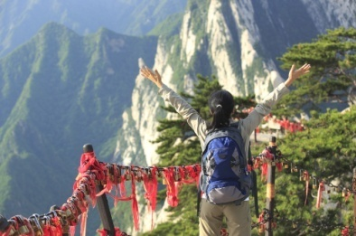
Excursions
- Sightseeing buses should be able to accommodate tourists with physical disabilities and should provide both audio and visual information and other assistance to blind and deaf people en route
- Wherever possible sightseeing companies should employ sign language interpreters for deaf and hearing-impaired tourists and/or printed descriptive material at all visit sites.

Conference facilities
- In addition to the other characteristics mentioned earlier and applying to buildings (entrances, telephones, toilets, signing, elevators and parking facilities), conference areas should be equipped with adequate seating facilities or reserved sections for persons in wheelchairs as well as special hearing devices or magnetic induction loops for persons with hearing impairments.

2.7 Optimise compliance with host enterprise policies and procedures, and host country legal requirements while on tour

Introduction
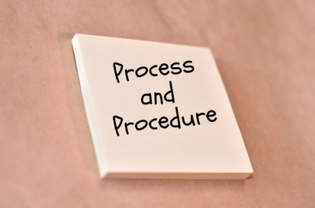
The objective of this task is to understand operating procedures, processes, policies and service delivery standards of the host organization.
Policies, procedures and standards provide guidance for fair and consistent staff treatment, conduct and levels of service across the organization. Each venue would incorporate its policies and procedures into a Standard Operating Manual or Employee Handbook which is made available and accessible to each worker.
The critical thing is that you become familiar with the policies and procedures as they apply at each particular venue.

Policy
A policy is a concise formal statement which indicates how the organization will act in a particular area of its operation. It provides employees with the approved way of operating in relation to a particular matter. Policies are important as they provide guidelines to ensure all employees are treated fairly and act in a consistent manner. They provide a link between what the business wants to achieve and the actual practice.

An example
The organization may have an 'alcoholic beverage consumption' policy which defines the way in a tour guide or drivers can consume alcohol during the duration of a tour.
For example:
- A tour guide may have one alcoholic beverage with dinner
- A driver may not consume alcohol four hours prior to driving.

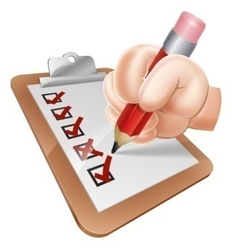
Procedure
A procedure is a particular way of doing things, such as a set of steps that must be followed to achieve a desired result. Organizations use procedures to ensure that jobs are done as efficiently as possible, following a step by step process. Procedures provide a logical way to implement policies.

An example
The organization may have a procedure used to ensure all tour members are present and accounted for prior to the tour moving to a new destination.

Standard
Standards are specific actions or rules designed to support a policy. They make the policy more meaningful and effective by providing the specifications which define the policy. They can be imposed by the venue, the industry or can be legal requirements.
The World Federation of Tourist Guide Federations (WFTGA) has developed a Code of Guiding Practice. This is a set of guidelines and behaviours which members of this organization are expected to follow to ensure good guiding practices. This is a standard supported by industry.
For further details refer to http://wftga.org.
By providing a manual to each employee, the organization is able to clearly articulate its expectations. The manual then becomes a guide for the employee on how to work efficiently and professionally within the host organization framework.

Access and read venue policies, procedures and standards

The Standard Operating Manual is a compilation of the policies, procedures and working conditions of the host organization. It also generally contains a code of conduct for employees which set guidelines around appropriate behaviour for the individual workplace. In the event that the guidelines are not followed, discipline processes will be implemented.
Some organizations will provide the manual in a hard copy format on signing of a formal employment contract. Employees are often expected to review the contents of the Standard Operating Manual and sign a statement demonstrating that it has been read and understood. The employee will also be asked to agree to abide by the contents.
It is not uncommon for organisations to post their policies and procedures on to the enterprise intranet. It is the employees’ responsibility to ensure they are familiar with the policies and procedures which specifically relate to their role.
If you are uncertain about the location of, or how to access, the Standard Operating Manual contact the Human Resources department of the host organization or speak to your supervisor.

Identify the areas to which venue policies, procedures and standards apply as appropriate to designated position

A Standard Operating Manual will consist of all policies, procedures and standards required by the organization to run efficiently and professionally.
Generalist policies may cover such things as:
- Leave - annual, bereavement, maternity, sick
- Staff presentation
- Staff use of facilities
- Absenteeism
- Emergency evacuation procedures
- Staff performance appraisals
- Remuneration
- Privacy and confidentiality
- Ethical treatment of employees
- Immigration and related documentation and requirements.
This is not an exhaustive list but demonstrates the types of policies that would apply to all employees. However, not all policies and procedures are relevant to all employees.
For a tourist guide there will be certain areas of policies and procedures that will be specific to that position.
Specific tour related policies and procedures

Lost or found items
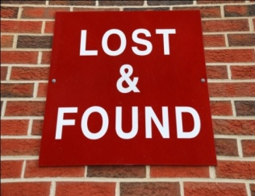
The organization will have procedures which must be followed in the event that a guest loses any items. This will be discussed further later in the training manual (E1.6 Complete lost and found documentation).

Troublesome Guests
Dealing with troublesome guests is, unfortunately, part of the tourist guide’s duties. To ensure this is done in a way that protects other guests and the tourist guide, an organization will have a procedure to follow which will provide you with guidelines to diffuse the situation and effectively deal with conflict.

Guest complaints
Grievance policies and procedures ensure that all guest complaints are dealt with fairly and in a timely manner. Often they will be accompanied by an appeals procedure that provides the guest with an additional avenue of redress if they are dissatisfied with the original outcome.
This is not an exhaustive list of policies and procedures relevant to the role of a tourist guide. Depending on the type of venue or attraction you work for, there may be others more specific to that role. If you are aware of their existence and know how to access them quickly, they provide great assistance in dealing with unusual circumstances.

Work Projects
It is a requirement of this Unit you complete Work Projects as advised by your Trainer. You must submit documentation, suitable evidence or other relevant proof of completion of the project to your Trainer by the agreed date.
2.1 Advise tour group members of tour:
Please identify considerations when conducting the following activities:
- Getting ready to greet participants
- Greeting of participants
- Welcome customers
- Giving introduction of tour
- Group rules and regulations.
2.2 Maintain adherence to the tour itinerary to the greatest extent possible:
- Explain how you can maintain adherence to the tour itinerary.
2.3 Provide tour-related advice and information to the tour group members:
- Identify information on local attractions and activities that can be provided to tour members that are part of your tour.
2.4 Supervise movement and activities of the tour group:
Explain how you can:
- Control group movement
- Locate lost or late tour group members.
2.5 Encourage tour group members to participate in the tour:
- Explain how you can involve participants
- Prepare one activity that can be used to involve tour members.
2.6 Meet identified special needs of tour group members:
- Explain how to recognise and accommodate special needs of a tour group.
2.7 Comply with policies and procedures:
- Identify types of specific tour related policies and procedures.

Summary

Co-ordinate tour group movements and activities
Advise tour group members of the type of tour and the proposed movements and activities and
- Types of tour group members
- Types of tours
- Getting ready to greet participants
- Greeting of participants
- Welcome customers
- Giving introduction of tour
- Explain the tour itinerary
- Procedures at tour stops and time spent at each stop
- Health and safety procedures
- Local regulations
- Group rules and regulations
- Specific site procedures
- Cultural considerations
- Environmental considerations.
Maintain adherence to the tour itinerary to the greatest extent possible
- Maintain adherence to the tour itinerary
- Changing the itinerary
- Need for a contingency plan.
Provide tour-related advice and information to the tour group members
- Familiarise self with locations
- Importance of non-verbal and verbal communication skills
- Using basic communication to deliver commentary
- Deliver your commentary
- Provide tour-related advice and information
- Provide information on local attractions and activities
- Consider audience learning styles.
Supervise movement and activities of the tour group
- Supervise movement and activities
- Counting participants
- Locate lost or late tour group members
- Managing tour group in crowds.
Encourage tour group members to participate in the tour
- Focus on tour members, not yourself
- Importance of positive attitude
- Ways to involve participants
- Providing hands-on or participatory activities.
Modify planned activities, add new activities and/or delete activities where required to meet identified special needs of tour group members
- Types of special needs
- Recognising special needs of group
- Accommodating special needs
- WTO - Accessible tourism for all.
Optimise compliance with host enterprise policies and procedures, and host country legal requirements while on tour
- Policy
- Procedure
- Standard
- Access and read venue policies, procedures and standards
- Identify the areas to which venue policies, procedures and standards apply as appropriate to designated position
- Specific tour related policies and procedures.

Element 3:
Facilitate tour group interaction with each other and the tour environment

3.1 Introduce tour group members to each other, where appropriate

Introduction

It is important to encourage interaction between tour group members.
If your tour group members are part of a group from the same school or business, you may not need to actively encourage interaction as they would know each other anyway.
However, you may be leading a group that is a collection of individuals. Interaction between group members can provide opportunities for the participants to have more fun and learn from each other:
- The use of name tags provides the group with a passive way to know each other's names
- An "icebreaker" is an activity conducted at the beginning of a tour that provides people with the opportunity to get to know each other briefly and quickly.

Example – Interaction name game
"The Name Game" is a quick icebreaker that requires no materials and takes very little time. It is best with small groups.
- Arrange the group in a circle
- The first person gives their name and an adjective that starts with the same letter - intelligent Ingrid
- The second person recites the first person’s name and adjective, and then their own with an appropriate descriptor - intelligent Ingrid, green-eyed Geoff
- The third person recalls the first two and then one of their own - intelligent Ingrid, green-eyed Geoff, tall Terri
- The activity continues until all people in the circle have completed the activity.
Throughout the tour, you may conduct activities that require the group to work together.
For example:
The name tags you are using on your tour of the zoo have been customized. Everybody has a name tag shaped as a different animal. On the back of each name tag is a piece of trivial information about that particular animal. As you approach each enclosure you ask the tour group member with the relevant name tag to take off their name tag and read out the information.



An elephant cannot jump
Ian

You can also use group interaction as a group management strategy.
For example:
You are taking a group of 20 middle school children around the local heritage Railway Station. Each of their venue kits features a picture of ten different types of railway wagons. Each student has to find the person with the same railway wagon picture as their own. During the tour they must stay with their person.
This enables you to have ten pairs of two children to manage rather than 20 individual children.
DO NOT force interaction on a group. If they are not comfortable with this, they will resent you for forcing it upon them. MOST people, however, enjoy the opportunity to get to know their fellow group members.

3.2 Explain the objectives and opportunities provided by participating in the tour

Introduction
Tour guides must be aware of the objectives for every tour they deliver including any themes that apply.
Differences in objectives and focuses for themes have clear implications for the activities to be included, the tenor of the tour, and the commentary and information provided.
It is also essential that tour members understand the objectives of the tour. You may find that the tour members, as a collective, may have additional objectives that can be accommodated in a tour to add value to a tour.

Types of tour objectives and themes
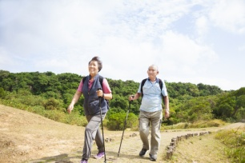
Objectives may include one or more of the following:
- Education
- Experience
- Relaxation / Fun
- Excitement
- Celebration of an event/historical date
- Money raising – for a person, club or organisation
- Recreation.
Themes for tours relate to a common thread that runs through a series of tours.
For example a group may visit multiple venues and have a theme across all of their tours such as:
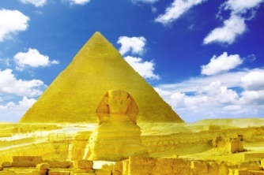
- Language
- Music
- The environment
- Culture
- Arts
- Animals
- Food.

3.3 Use techniques to build and maintain group cohesion on tour

Introduction
In Section 3.1 of this manual we explored the importance and ways of tour members to meet each other. In this section, we will ways to build and maintain group cohesion.
Whilst it is important to try to have a group who can travel and interact with harmony with each other, the approach taken towards each group in building group cohesion will vary, given that different tour group sizes, personalities and various dynamics will differ from group to group.

Techniques to build and maintain group cohesion
Techniques to build and maintain group cohesion may include:
- Utilising initial introduction techniques
- Encouraging interaction between group members
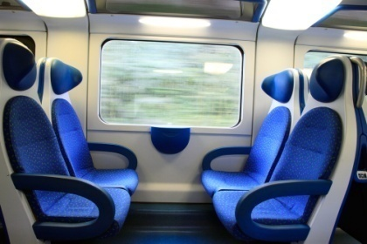
- Initiating group activities or games
- Inviting individuals to address the group
- Utilising the skills of individual tour group members within the tour
- Focusing the group on shared experiences
- Using seat rotations systems
- Creating opportunities for individual interaction
- Accommodating individual preferences, where possible
- Keeping group informed about the itinerary and planned changes
- Facilitating attempts at group cohesion
- Creating and supporting attempts to optimise goodwill and group morale.

Building rapport

‘Rapport’ refers to the relationship between tour guides and the tour group members.
Tour guides must strive for a rapport which is positive, friendly and understanding. A good rapport is one where all parties share similar feelings and agree about the majority of things.
Tour guides should start rapport building as soon as they meet a tour group member.
A good rapport is important because it:
- Enhances visitor engagement
- Sets the scene for a better experience
- Helps overcome small problems that crop up
- Encourages repeat and referral business.

Rapport-building techniques
Good rapport-building costs nothing but does require some effort.
Techniques to build rapport with participants may include:
- Extending/building on conversations when you greeted people – such as:
- Remembering and using the person’s name
- Mentioning something talked about as part of the previous contact

- Checking to ensure something they queries earlier has been resolved to their satisfaction
- Asking participants questions – about topics such as:
- Their country of origin
- Personal interests and specific interests for this tour
- Their reasons for being on tour
- Their previous experiences and tours
- Using icebreakers – these are quick exercises which can be used to ‘break the ice’ and introduce tour group members to each other.
They are really only suitable where:
- The participants do not already know each other – if the group members already know each other than iced-breakers are often not appreciated and many resent having to participate in them
- There is sufficient time to conduct them – they can be quite time consuming
- A suitable, comfortable location exists to do them – standing in the heat is not a good location
- Using anecdotes when interacting with participants – these are short stories relevant to the site, location or up-coming tour and are used as they add interest and provide insight into the experience
- Using humour when talking with people – most tours contain an element of fun and the use of appropriate humour at appropriate times can set the scene for fun and actually impart fun and enjoyment before the tour starts
- Checking on people’s welfare – by asking if they need anything, verifying they are okay and prepared, and helping them solve their problems
- Applying suitable interpersonal and communication skills at every opportunity/exchange – such as:

- Smiling
- Eye contact
- Demonstrating interest
- Responding to questions
- Clarifying information.
- Involving them in what is happening – this can include:
- Telling them what is about to happen
- Giving them something to do – this may even extend to giving them a simple task to assist you, depending on nature of tour and organisational policies
- Giving them something to look at or read.

Considering cultural characteristics
The basic protocols for addressing cultural differences are:
- Respect the other cultures
- Try to obtain an interpreter where advance knowledge of language difficulties have been identified
- Develop handouts, materials and events and activities which are sensitive to cultural needs. This may include not inviting or expecting participation of certain family members, age groups
- Never try to impose your cultural beliefs or protocols onto tour group members
- Realise many tour group members expect a difference in cultures. For many this can be one of the reasons they visit different countries and participate in tours

- Try to involve those from different cultures to the same extent you try to involve others. Do not ostracise them and never make them feel they are being treated differently based on their culture, race, nationality, dress or religious beliefs
- Make an effort to learn about the country and cultures of your main groups – so you have a better understanding of their culture, preferences, society and ways of living
- Learn some basic words and phrases to use on participants from commonly hosted tours this indicates you have made an effort and value their presence.
- Start with the basics such as “Hello”, “How are you?”, “Nice to meet you”, “Please”, “Thank you” and “Goodbye”.

3.4 Share and explain general rules that apply to group members while on tour

Introduction
As previously mention in this manual, there are many pieces of information that must be provided by tour guides to travellers. This information is provided for various reasons including but not limited to:
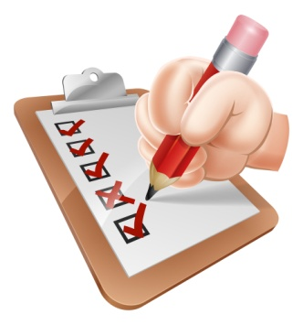
- Making them aware of the tour and it included activities and attractions
- Ensuring scheduled activities can be undertaken
- Ensuring all team members can enjoy the tour
- Ensure tour members understand different rules and laws for individual countries and attractions
- Ensure tour members understand safety requirements and emergency actions.

Types of general rules
Naturally each tour will have general rules that must be communicated to tour members. These rules are normally communicated at the commencement of a tour.
General rules may include:
- Acceptable and unacceptable behaviour in relation to other tour group members, local/host communities and in relation to scheduled activities and sites

- Respect for others and the environment
- Need for sharing
- Need to observe time constraints
- Basic requirements to ensure safety and security of tour group members and their possessions
- Action to take in the event of an accident or emergency
- The need to communicate and provide feedback to tour leader.

Making initial announcements
All tours will require announcements of some sort to be made prior to the tour commencing.

Issues to address
- Location of facilities
- Do’s and Don’t’s of the tour
- Advice on what to do if a person becomes separated from the group

- Safety precautions. Advising tour group members about safety precautions can include:
- Screening a video/DVD
- Reading a prepared screed
- Distributing safety equipment and/or protective clothing
- Demonstrating how to use safety equipment
- Assisting participants with using/wearing their safety items
- Site policies

- Encouragement to group to enjoy, participate and engage with the tour and all its activities and inclusions
- Specific invitation to the group to:
- Ask questions throughout the tour
- Notify tour guides if they are feeling uncomfortable or unwell
- Tell tour guides should they become injured, distressed or become aware of anything jeopardising the safety of the tour group.

3.5 Balance the needs of the group with individual needs

Introduction

At all times you must consider the needs and wishes of tour group participants from the moment they arrive on site to begin their tour, to the moment they depart the site/venue.
This is an on-going, non-negotiable requirement applying to all members of all tours, without exception.
This section recaps some previous advice and presents new advice designed to optimise individual participant enjoyment of, and satisfaction with, their tour experience.

The vast majority
It must be said the vast majority of tour group members are easily pleased when on tour.
If they are treated politely, informed about what is taking place and receive what they were told they would receive, most tour group members are satisfied and do not require high levels of attention.

However, the Pareto rule seems to apply to many tour groups – 20% of the tour group demand 80% of your time and attention.
This means most in the tour group are happy to ‘go along and get along’ while a minority will require extra attention, more consideration, deferential and preferential treatment and a higher level of maintenance.
This understanding, of course, does not mean 80% of the group can be ignored or taken for granted!

Consider needs and wishes of participants
Considering the needs and wishes of participants may include allowing for:
- Quiet time – to allow people time to relax and savour a view or experience. This highlights the need for you to understand you do not have talk all the time as a tour guide

- Free time – for tour group members to do their own thing. Most tour group members will want some time to do what they want as opposed to doing what has been organised for them. This highlights the unique nature of individuals
- A time for people to chat – this may involve chatting amongst themselves, chatting with other people they meet on the tour or chatting with you
- Personal enjoyment of site – this is time enabling tour group members to enjoy the tour as best suits them, rather than as imposed by the tour itinerary
- Some people will prefer a passive orientation where they simply watch and listen while other will want a more active approach where they interact with people and activities
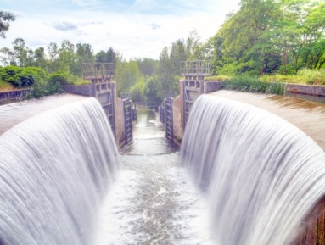
- Tour group members to have a rest – it is important to monitor the group regarding rest breaks and vital you understand your level of fitness does not dictate the opportunities for participants to rest and recuperate
- Photo opportunities – always be alert to the need for people to take photographs top record their experience.
Many of these ‘photo opportunities’ are predictable and will remain the same for every tour but there are always unique moments which can arise where people wish to capture the moment.
Not being able to take photographs to suit individual need is a major source of complaint or dissatisfaction so be aware of the need to facilitate this.
Be prepared, for example to:
- Allow extra time where everyone is taking photographs – if there is a need to save time to keep the tour on schedule try to save it somewhere else and not at the expense of restricting photos taken by the group
- Offer to take photographs for individuals – so they can be ‘in the photo’
- Be part of the photo – many people will want you to be part of their photograph
- Assist with the photo – be holding bags and other items
- ‘Up close and personal’ opportunities – tour group members expect many things of those who deliver tours and one of their main expectations is the presence of you as a tour guide will gain them access to things that are not available to people who are not on a tour
- This means they may seek out or ask tour guides to organise:
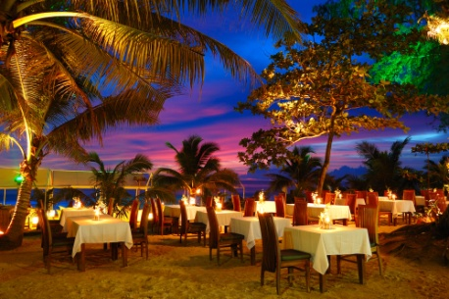
- A meeting with other people at the site or venue
- Access to areas which are ‘off limits’ to other people or are not part of a tour
- Introductions and more contact with other staff who are available – so they can talk more with the, ask them questions or watch them at work
- Special photo opportunities with animals, characters or unique sights
- Preferential treatment – this often relates to ‘small things’ but things which are important to the tour group members, such as:
- Being served first when meals are taken – as opposed to having to queue in line with the general public
- Being able to sit together for meals– as opposed to having to take whatever seats are available
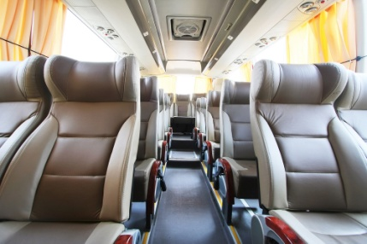
- Being given the ‘best’ seats’ when dining – seats with the best view, least disruption by pedestrian traffic
- Going to the front of queues for rides, activities, displays, events etc.
- Being loaded first onto transport so they can ‘sit with each other’ and get the ‘best seats’.

Assessing tour group needs
When delivering tours tour guides are expected and have an obligation to monitor the needs of their group on an on-going basis.

Methods of monitoring needs
The ways to monitor and assess the tour group and their possible needs while on tour are:
Visual observation
Watching the group and individuals within it to determine their needs and identify if any problems are emerging.
The key is to observe and interpret their body language with special attention paid to facial expression.
Do they look tired or distressed? They will exhibit drooped shoulders, pained expressions, slow movement and may be holding onto others. They may be straggling and have dropped off the main tour group.
Or do they look comfortable and happy? They will have shoulders back, be alert and smiling, and joking with others.

Listening to comments made
These are comments made by people to other tour group members, or their partners or sub-group.
Comments which could give rise to concern are the obvious ones such as “I’m tired”, “I need a rest” or “I am not feeling well”.
Similarly an outburst from one tour group member directed at another tour group member would likewise give cause for concern.
Being informed directly by someone
This may take the form of a tour group member:
- Telling you they are tired and asking for a rest break
- Saying to you they are feeling unwell and want assistance
- Advising you they are being annoyed or upset by someone else in the group.

Asking regular questions of the group or individuals within the group
This helps to determine if they are okay or not.
Encourage comments
Creating an environment which encourages them to inform you if they have any issues, concerns or personal requests.

Issues to monitor or address
You should pay attention to the following:
- Pointing out nearby washroom and rest room facilities – so people can use the toilet or freshen up
- Selecting suitable sites for delivering information, commentary or responding to questions or requests – such as a shady or dry spot, or one protected from the wind

- Verbally informing people how long (in terms of distance or time) until the next stop, site, refreshment stop
- Keeping the group together, physically – and not allowing stragglers
- Addressing problems between members of the group – there can be situations where friction exists between members of a tour group and this manifests itself in ways which threaten the harmony and cohesiveness of the group
- Asking people to modify their behaviour or language – where, for example, their actions are:
- Culturally insensitive:
- Socially unacceptable
- Illegal
- Threatening or intimidating to others
- Causing anxiety, distress or ill-feeling within the group.

Balancing the needs of the group with individual needs

Balancing the needs of the group with individual needs may include:
- Introducing supplementary activities to cater for identified need
- Ensuring inclusiveness to the greatest extent possible
- Explaining unique individual needs to the group and asking their permission for special treatment of the special needs person.

Work Projects
It is a requirement of this Unit you complete Work Projects as advised by your Trainer. You must submit documentation, suitable evidence or other relevant proof of completion of the project to your Trainer by the agreed date.
3.1 Introduce tour group members to each other:
- Explain how you can introduce tour group members to each other.
3.2 Tour objectives and opportunities provided by participating in the tour:
- Identify tour objectives and themes for your tour.
3.3 Building group cohesion:
- Identify how you can build and maintain group cohesion.
3.4 Identify tour general rules:
- Identify five general rules that would apply to your tour.
3.5 Balance group and individual needs:
- Explain how you can assess tour group needs
- Explain how you can balance the needs of the group with individual needs.

Summary

Facilitate tour group interaction with each other and the tour environment
Introduce tour group members to each other, where appropriate
- Example - Interaction name game.
Explain the objectives and opportunities provided by participating in the tour
- Types of tour objectives and themes.
Use techniques to build and maintain group cohesion on tour
- Techniques to build and maintain group cohesion
- Building rapport
- Considering cultural characteristics.
Share and explain general rules that apply to group members while on tour
- Types of general rules
- Making initial announcements.
Balance the needs of the group with individual needs
- The vast majority
- Consider needs and wishes of participants
- Assessing tour group needs
- Issues to monitor or address
- Balancing the needs of the group with individual needs.

Element 4:
Deal with on-tour problems

4.1 Predict the potential for problems and take appropriate avoidance action

Introduction
There are many potential problems that may arise during the duration of a tour. To date, we have explored some of these problems however this section will focus on how to:

- Understand the importance of maintaining the health and safety of participants
- Handling emergency situations
- Handling conflict
- Handling dissatisfied customers
- Maximising tour member enjoyment.
Before we look at how to anticipate and deal with various types of problems, firstly it is important to understand:
- How to identify potential problems
- Basic steps when handling problems

Predicting the potential for problems
Whilst each situation may require different methods of identification, predicting the potential for problems may include:
- Monitoring people – including their verbal and body language
- Monitoring the physical and natural environment
- Liaising with other staff

- Encouraging tour group members to communicate indicators of emerging or existing problems.

Ensure correct handling of problems
Tips tour guides must use when handling problems include but are not limited to:
- Realise no problem will ever resolve itself
- All identified issues or problems must be addressed
- Treat people with respect
- Try to stay calm
- Look through the eyes of the tour group member and try to see things from their perspective.

Importance of safety and security of participants
Naturally the most important 'problem' that must be kept to a minimum relates to the health, safety and security of staff and tour members.
All tours have an obligation to protect the safety and security of tour group participants and their belongings.
It is a standard rule, however, the safety of people comes before the safety and security of property and belongings.
Safety and security is important to optimise tour group member satisfaction with their tour experience, and to discharge common law duty of care obligations.

The following must also be taken into account when delivering tours:
- Explain potential hazards and dangers to tour group members
- Identify action to take to address and manage risks
- Never assume tour group members know of risks and dangers
- Prevent access to unauthorised or dangerous situations and environments
- Modify, halt or divert a tour whenever dangerous situations occur
- Distribute and demonstrate safety equipment and clothing
- Check seat belts, harnesses and restraints

- Monitor personal belongings
- Check their comfort levels and respond appropriately if they are tired, too hot, or unwell
- Give safety and security the time and priority it deserves
- Take action to address any unsafe situation
- Always be willing to call for assistance from other staff, security or the authorities.

Safety policies and procedures
Types of safety policies and procedures that tour guides must follow include:
- Learn how to apply basic first aid
- Record the facts of any situation where there is a safety or security problem
- Be prepared to give instructions and directions to the group when a problem emerges
- Realise there is increased potential for harm if children are present on tours
- Do not allow tour group members to attempt the rescue of other people
- Never put themselves in harm’s way
- Aim to avoid trouble and danger rather than having to respond to it
- Observe people and warn them if they are straying away or moving towards/into danger.

4.2 Assess and respond to emergencies and unexpected events


Introduction
An emergency is anything with the potential to cause injury to a person, or harm to property.
It is a situation that you cannot immediately, totally and successfully deal with, without the risk of harm to yourself.
An emergency may involve just one person, or many, or it may involve damage being done to guest’s property or the property of the establishment.
An emergency also includes the threat of injury or the threat of damage. This means that the injury or damage does not have to occur first in order for there to be a real emergency.

Different types of emergencies
The different types of emergencies in a tour situation could include, but are not limited to:
- Lost people
- Lost documents including passports
- Lost luggage, phone, laptops, jewellery and other valuables

- Fire
- Medical emergency
- Bomb threat
- Hostage situation
- Robbery
- Difficult customers
- Power failure.
The Emergency Management Plan should have investigated possible emergencies likely to occur and planned actions for dealing with each of them.

Understand emergency equipment
Before we can identify how to handle emergencies, it is vital to understand emergency equipment that may be used in an emergency situation.
Providing prompt first aid assistance in the event of a medical emergency or being able to locate a necessary item to help deal with an emergency, can mean the difference between a minor event or a major event.
Being able to quickly help a tour member who has hurt themselves can make the difference between minimal disruption and potential serious illness.
Every establishment must provide various items of emergency equipment, so it is important tour guides know where these items are, and how to use them.

They are not expected to be an expert in first aid or to be a professional fire-fighter but the employer and guests do expect that they know the basics and are ready and able to put them into practice when the need arises.

First aid kits
Tour guides must know:
- Where these are located
- What is in them
- How to use the items they contain.

Emergency documentation
It is vital to understand any internal documentation needs to be completed in the event of different types of emergencies.
The importance of maintaining accurate emergency documentation includes:

- Incident reporting
- Legal requirements
- Insurance purposes
- Medical information
- Accident investigations.

When you have to use the first aid kit
The tour guides’ main job is to be able to provide basic first aid only and to call medical help when the medical emergency requires more than the basics.
Even where they are unable to treat a badly injured person, they should remain with them, once professional assistance has been called, comfort them and re-assure them help is on the way.

Fire extinguishers
Too many tour guides don’t know where their fire extinguishers are, then when they are needed valuable time is spent looking for them.
You must make it a first priority to know where every different fire extinguisher is in the place where they work.
In addition tour members should also be made aware of their location and use, in the event that tour guides are not present or are involved in the emergency themselves.
Tour guides must also make sure they know:
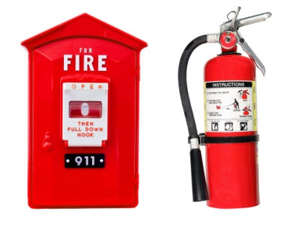
- How to identify the different types of portable fire extinguishers
- What extinguishers can be used on what types of fires
- How to operate the extinguishers effectively
- Where the fire hoses are and how to operate them
- Where sand buckets are located
- Where the fire blankets are and how to use them.

Torch lights
Torches are useful in the event of night time emergencies, fires or where power is not available or disrupted.
Given that tours are conducted in places and locations which is not familiar to both tour guides and tour members, the need for emergency torches is vital.
Tour guides must know:
- Where your torch lights are located
- How to operate them
- How long they will last.

Responding to emergencies
Following are some courses of action tour guides may take in the event of an emergency.
Note: The prescribed course of action will differ between organisations and types of tours, so tour guides must research establishment policies and emergency procedures, and follow them.
Saving a life must always take precedence over saving material items.
Responding to emergencies and unexpected events may include:

- Implementing emergency and contingency plans – including taking charge and issuing directions for action, evacuation or first-line response
- Notifying the authorities
- Seeking assistance from emergency services
- Placing the safety of people above the protection of assets
- Minimising harm, damage and disruption.

Three important basic requirements
The three basics will always be:
- Immediately contact an internal or external authority to notify them of the situation and obtain help
- Protect guests, their property and the venue – evacuation of tour members is the most important aspect of this
- The protection of people always takes priority over the protection of property – saving lives is more important than saving property.


Handling medical emergencies
There are a number of reasons why a medical emergency occurs during a tour including:
- Injury as a result of an accident, fall, or trip
- Injury as a result of an emergency incident – an assault or overdose situation
- Due to a medical condition – heart attack, asthma attack, heat exposure, diabetic coma, etc.
For serious accidents and incidents an ambulance must be called. After calling for an ambulance, the emergency operator will ask:
- The location – including a cross street (if possible)
- To answer a series of questions about the patient’s condition and what first aid may have already been rendered.

An ambulance is normally dispatched after a location and a brief description of the patient, their condition and details have been given. However, the emergency operator may require the tour guide to stay on the line so they can fully ascertain the level of the emergency and the patient’s condition.
Emergency ambulance call takers are also trained to give medical advice over the telephone to assist with the patient’s needs until the ambulance arrives.
Tour guides must ever assume they know what is wrong with a patient. There are many different medical conditions that can present the same set of symptoms.
It is important that tour guides don’t move the patient unnecessarily or take a particular course of action unless advised otherwise by trained medical staff.

Handling unexpected events
Tour guides may need to adjust a tour to suited unexpected events.
Unexpected events can be classified as:
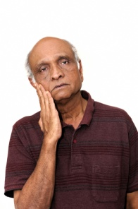
- Negative events – such as accidents and emergencies
- Positive events – happenings which were not anticipated but which add value and another element or dimension to the tour.

Negative events
Causes of unexpected events which can negatively impact a tour could include:
- Weather
- Strikes
- Mechanical failure
- Luggage problems
- Theft
- Injury or accident

- Inappropriate participant behaviour
- Sudden closures of sites
- Equipment failure
- Poor road conditions or unexpected high traffic flows (or vehicle accidents) causing delays
- Festivals or community gatherings.
Dealing with them requires tour guides to:
- Advise the tour group members immediately, yet in a sensitive manner, of changes the event has caused to the itinerary

- Tell the group of the new arrangements, schedule and itinerary
- Try to replace any exclusions with replacement inclusions
- Always adhere to organisational policy and practice
- Be positive and sell the new arrangements to the group
- Advise management of changes
- Ensure tour group needs are still met to the best extent possible
- Cancel forthcoming similar tours, arrangements or rebook revised arrangements which accommodate the cause of the alterations.

Positive events

These are occurrences which crop up unannounced and unexpected while the tour is in progress.
They may include:
- Special sightings of wildlife
- A natural weather or other event which is unique and interesting
- An unexpected occurrence of any sort which does not pose risk
- Opportunities for engagement or activity not scheduled but which have previously been previously undertaken.
Adjusting the tour may involve:
- Stopping, pausing or delaying the tour while participants see, hear or otherwise experience the unexpected event
- Adding information, context and detail about the event based on product, site or general knowledge
- Joining with the group in wondering at the ‘surprise’ happening and sharing their excitement

- Telling group members about how rare ‘this event’ is
- Explaining why the event is so unique
- Omitting another aspect of the commentary so the ‘new’ material can be presented without adversely impacting the timing of the tour.
Dealing with delays
Delays are events which cause a pre-defined itinerary to deviate from its original schedule. If faced with delays you need to:
- Liaise closely with those responsible for the delay to assess the situation
- Advise the clients immediately, accurately inform your group of the reasons for the delay
- Explain to the group the action being taken to manage the situation
- In many cases you will have to do some quick thinking and devise an alternative plan
- Advise suppliers and others affected by the delay, according to company policy.

4.3 Resolve person to person conflict

Introduction
While most people who go on tours are generally there to have a good time there are times when conflict issues arise.
These can occur between passengers or between the tour guide and a passengers.
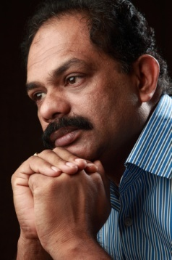
Regardless of the type or purpose of conflict the situation must be defused and resolved as quickly as possible:
- To the satisfaction of both parties, if possible
- With minimal disruption to other tour members
On tour, when issues which have been brewing between group members, tour guides to take control of the situation.
Always remember:
- It must be tour guides who is in control of the tour
- Tour guides must never be afraid of asking for help or back-up from management, other staff or security.

Types of person-to-person conflict
Person-to-person conflict may include:

- Conflict between tour group members – including intra-family conflict
- Conflict between tour group members and non-tour group members – including members of the public and staff related to third-party carriers or providers
- Conflict between tour group members and host enterprise tour guides and other staff members
- Conflict involving authorities
- Conflict involving local communities
- Dominant, domineering or disruptive group members – including those affected by alcohol or drugs
- Sub-groups or cliques within the wider tour group
- Perceptions of favouritism by tour leader to certain tour group members.

Reasons for conflict
There are many reasons for disharmony on a tour. These include:
- Differing cultural values- i.e. punctuality is important for some cultures but not others
- Prejudices
- Age groups - groups may be made up of several sub group who have different needs and wants
- Questioning of the professionalism of those responsible for the tour.

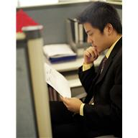
Actions to resolve conflicts

At the beginning of each tour
The tour guide must establish his or her credibility and authority with the group and relay the procedures, routines and rules of the tour to ensure that the tour proceeds with minimal conflict and problems.
They should also use the pre tour brief to gain valuable background information about the group and individuals.

During the tour
The tour guide should:
- Observe behaviours

- Be well prepared, authoritative, happy enthusiastic and considerate.
- Be accessible to all clients on tour and be willing to communicate with every member of the tour group.
- Don’t favour some members over others.

As conflict arises
Some situations can be resolved simply via communication, authority and leadership.
A tour leader should always have an action plan for those more difficult situations.
This gives the guide more confidence when dealing with difficult situations.
Tips for handling problems with tour group members:
- Realise no problem will ever resolve itself – problems require you take action to fix or address them. You must take responsibility for taking action
- All identified issues or problems must be addressed – you cannot afford to know a problem exists and then simply ignore it

- If appropriate, look for ‘safety angle’ on which to focus the conversation you need to have. People are more likely to listen and comply if you can demonstrate they need to alter what they are doing because it is unsafe or poses a risk to others
- Treat people with respect – talk politely with them allow them their dignity
- Aim to make the other person feel special, not to feel victimised
- Try to stay clam – when a need to intervene and say something to a participant arises
- You need to ‘act’ but not ‘over-react’, so avoid loud voices and try to speak to the person away from others so the conversation is private, and so the participants do not feel as if they are being reprimanded in front of the rest of the group and being made to look silly or ‘small’
- Phrase what you say so it is not a personal ‘attack’ on the other person – for example, instead of saying “You must not do that”, re-phrase the statement to “We prefer such action does not take place while here”
- Try phrasing statements asking people to modify their behaviour as ‘requests’ rather than ‘commands’, and add reasons why the request is being made
- There is big difference between ‘Stop doing that’ and “Could I please ask you not to do that because it scares the animals?”
- Look through the eyes of the tour group member and try to see things from their perspective.
For example, you might say “I can see you are tired and I know we have walked quite a long way and it is hot, but I need you to know it is not acceptable for the safety of others for you to wander off on your own to have a rest”.
- You may also share with them you, too, are feeling the same way they are which helps to legitimise the way they are feeling.

Dealing with conflicts between group members
Techniques to address these types of situations include:
- Ask the two parties to come to one side and talk with you – it is important everything that is said is spoken in front of both parties so there can be no suspicion/question over what is said
- Where the tour is long one, attention should be paid to trying to resolve the root cause of the issue – where the tour is a short one, attention should focus on developing a solution to effectively address the problem until the tour has finished
- Ask the parties what the problem is – this allows you to gain insight and also allows the parties to get things off their chest
- Explain how their behaviour is adversely impacting the enjoyment of other tour group members
- Ask them to refrain from further action which disrupts the tour – and thank them for their cooperation
- Be prepared to suggest solution as to assist resolve the issue in the immediate short-term, such as:

- Re-seating people to different locations so they are not near to each other, or are out of line-of-sight of the other person
- Asking parents to more closely supervise their children
- Re-grouping participants into different configurations so that those in conflict are in different sub-groups when it comes to things such as viewing, activities, dining
- Monitoring the situation – and being prepared to:
- Repeat previous requests
- Suggest alternative solutions
- Thank people for their cooperation.

Drug or alcohol affected clients

If any of your passengers are badly affected by drugs or alcohol tour guides need to:
- Consider the company policy
- Maintain a professional attitude, use sound judgment.
- Follow the laws of the community or country you are visiting
- Seek assistance from other persons.
In times of danger, their responsibility lies with the group.

4.4 Take action to resolve tour group member dissatisfaction with the tour

Introduction
Regardless of how professionally you behave, you may encounter customers who are dissatisfied. You can pick up hints that customers are dissatisfied prior to them making formal complaints or expressing their concerns verbally.
Customer satisfaction is often dependent on their experience matching their expectation.

The ideal situation occurs when the experience surpasses the expectation. This guarantees customer satisfaction.
Unfortunately experiences may not meet expectations. In some cases this may be due to unrealistic expectations or experiences caused by tour guides, their suppliers or factors out of anyone's control.
Whilst it is not possible to successfully overcome each and every dissatisfaction, steps must be certainly taken to identify and address each and every issue.

Importance of meeting expectations of participants

It is important to meet the expectations of tour group members in order to:
- Enhance their satisfaction with the venue and the tour
- Increase the likelihood of a repeat visit from the participants
- Optimise the chance participants will speak well about the venue, site or tour and recommend their friends and family also take a tour
- Raise the possibility of participants spending more money elsewhere in the venue such as by purchasing food and drinks, souvenirs, other tours, photographs.

Identifying customer dissatisfaction
Monitoring non-verbal communication from customers is very important to ensure that you pick up these hints before they become a problem.
Some non-verbal clues to look for are:

- Moving from one foot to another. This could mean that the tour group member is feeling uncomfortable
- Closed eyes for a moment during a conversation could means that they are trying to clarify something so they might not understand what you are saying
- Staring into the air or down at the ground could indicate that the person is disinterested in what you have to say
- Pointing an index finger at someone when having a conversation could suggest aggressiveness
- Head scratching might mean that the individual is puzzled or unsure about what is being said
- Clasping hands behind the head might indicate that the person is trying to control an angry feeling.
This is not an exhaustive list, but if you witness these or other negative non-verbal clues from your tour members, you should consider that they may be feeling dissatisfied.

Resolving group member dissatisfaction
Action to resolve tour group member dissatisfaction may include:
- Listening to the complaint to identify the cause

- Acknowledging the emotion involved in the dissatisfaction
- Suggesting or soliciting potential resolutions
- Agreeing on an acceptable solution, where possible
- Implementing the agreed solution, where practicable.

4.5 Seek to maximise tour group member enjoyment with the tour under adverse conditions

Introduction

It is not realistic for each and every tour to run as expected or planned.
There will always be challenges that must be faced in each and every tour. In previous sections some unexpected influences or events, be them positive or negative have been identified.
Whilst positive events enhance tours, negative events can greatly impact the enjoyment of a tour and its members.
It is important that even when adverse or negative factors impact on a tour, the tour guides themselves strive to optimise the enjoyment of the tour and the overall customer satisfaction.

Optimising customer satisfaction
A good tourist guide is the key to customer satisfaction, especially under adverse conditions.
Individual tourist guides will have their own style and technique, but there are a number of traits that all tourist guides must possess to ensure that customer satisfaction levels are high:
- Effective communication skills - verbal and non-verbal
- Common sense
- Confidence

- Flexibility
- Assertiveness
- Patience
- Empathy with tour group members
- Appreciation of cultural differences
- Research skills
- Organisational skills
- Calm in the face of adversity
- Passion for the subject
- Friendly approach.

Active listening skills

Whilst tour guides may not have great influence over adverse tour conditions, they do have influence over what customers say about them and how they can react to overcome adversity and hopefully maintain customer satisfaction.
Naturally tour guides should ask questions, encourage questions and solicit input from tour group members.
All of these activities make it critical you use ‘active listening skills’ when delivering tours.
Active listening is a way of listening and responding to another person so as to enhance your understanding of the conversation and includes:
- Paying attention and concentrating
- Never interrupting the other person
- Asking questions to clarify any information
- Not trying to guess what the other person will say.

Identifying what customers expect in adverse conditions
When adverse conditions impact on a tour, instead of trying to guess what can be done to overcome adversity, it is a wise idea to involve tour members themselves in thinking of alternate activities or attractions that can be added to a tour to help meet the satisfaction of customers.

Developing possible tour alternatives
As well as asking tour members what can be done to improve a tour, it is important for tour guides to help control the situation and think of possible alternatives that can be implemented.
This is important for a number of reasons including:
- Provides 'suitable and reasonable' activities that can possibly be done based on experience and past similar situations
- Ensures that alternatives are still cost effective
- Provides a list of suggestions that tour members may not have thought of
- Shows they are pro-active in trying to maintain customer satisfaction
- Steers focus towards activities that tour members can deliver.


Reach mutual consensus
Once a list of possible activities have been identified it is essential that both tour guides and tour members are involved in selecting suitable alternatives.
This ensures they feel valued and part of the process.

Work Projects
It is a requirement of this Unit you complete Work Projects as advised by your Trainer. You must submit documentation, suitable evidence or other relevant proof of completion of the project to your Trainer by the agreed date.
4.1 Predict and resolve problems:
- Identify four potential problems that may impact on a tour
- Identify solutions for each of these problems.
4.2 Respond to emergencies and unexpected events:
- Identify four types of emergencies that may take place on tour
- Identify how you would handle these emergencies
- Identify three possible negative unexpected events
- Identify how you would handle these negative unexpected events
- Identify how you would deal with delays.
4.3 Resolve person-to-person conflict:
- Role play how you would handle one type of person-to-person conflict.
4.4 Take action to resolve tour group member dissatisfaction with the tour:
- Importance of meeting expectations of participants
- Identifying customer dissatisfaction
- Resolving group member dissatisfaction.
4.5 Maximise tour group member enjoyment:
- Identify types of adverse conditions
- Explain how you can optimise customer satisfaction during adverse conditions.

Summary

Deal with on-tour problems
Predict the potential for problems and take appropriate avoidance action
- Predicting the potential for problems
- Ensure correct handling of problems
- Importance of safety and security of participants
- Safety policies and procedures.
Assess and respond to emergencies and unexpected events
- Different types of emergencies
- Understand emergency equipment
- Responding to emergencies
- Three important basic requirements
- Handling medical emergencies
- Handling unexpected events
- Dealing with delays.
Resolve person-to-person conflict
- Types of person-to-person conflict
- Reasons for conflict
- Actions to resolve conflicts
- Dealing with conflicts between group members
- Drug or alcohol affected clients.
Take action to resolve tour group member dissatisfaction with the tour
- Importance of meeting expectations of participants
- Identifying customer dissatisfaction
- Resolving group member dissatisfaction.
Seek to maximise tour group member enjoyment with the tour under adverse conditions
- Optimising customer satisfaction
- Active listening skills
- Identifying what customers expect in adverse conditions
- Developing possible tour alternatives
- Reach mutual consensus.

Presentation of written work

Introduction
It is important for students to present carefully prepared written work. Written presentation in industry must be professional in appearance and accurate in content. If students develop good writing skills whilst studying, they are able to easily transfer those skills to the workplace.

Style

Students should write in a style that is simple and concise. Short sentences and paragraphs are easier to read and understand. It helps to write a plan and at least one draft of the written work so that the final product will be well organised. The points presented will then follow a logical sequence and be relevant. Students should frequently refer to the question asked, to keep ‘on track’. Teachers recognise and are critical of work that does not answer the question, or is ‘padded’ with irrelevant material. In summary, remember to:
- Plan ahead
- Be clear and concise
- Answer the question
- Proofread the final draft.

Presenting Written Work
Types of written work
Students may be asked to write:
- Short and long reports
- Essays
- Records of interviews
- Questionnaires
- Business letters
- Resumes.
Format
All written work should be presented on A4 paper, single-sided with a left-hand margin. If work is word-processed, one-and-a-half or double spacing should be used. Handwritten work must be legible and should also be well spaced to allow for ease of reading. New paragraphs should not be indented but should be separated by a space. Pages must be numbered. If headings are also to be numbered, students should use a logical and sequential system of numbering.
Cover Sheet
All written work should be submitted with a cover sheet stapled to the front that contains:
- The student’s name and student number
- The name of the class/unit
- The due date of the work
- The title of the work
- The teacher’s name
- A signed declaration that the work does not involve plagiarism.
Keeping a Copy
Students must keep a copy of the written work in case it is lost. This rarely happens but it can be disastrous if a copy has not been kept.
Inclusive language
This means language that includes every section of the population. For instance, if a student were to write ‘A nurse is responsible for the patients in her care at all times’ it would be implying that all nurses are female and would be excluding male nurses.
Examples of appropriate language are shown on the right:
Mankind | Humankind
Barman/maid | Bar attendant
Host/hostess | Host
Waiter/waitress | Waiter or waiting staff

Recommended reading
Braidwood, B, 2000 (2nd ed’n), Tour Guiding Business, Self-Counsel Press.
Collins, V.R, 2000, Becoming a tour guide: principles of guiding and site interpretation, Continuum, London.
Knudson, D.M, 2003 (2nd ed’n), Interpretation of Cultural and Natural Resources, Venture Pub.
Kotler, P, Bowen, J.T. & Makens, C, 2010 (5th ed’n), Marketing for hospitality and tourism, Pearson, Upper Saddle River, New Jersey & London.
Levy, B.A, 2001, Great Tours! Thematic Tours and Guide Training for Historic Sites, Altamira Press.
Mancini, M, 2000 (3rd ed’n), Conducting tours, Delmar Cengage Learning, Victoria.
Morrison, A.M, 2010 (4th ed’n), Hospitality and travel marketing, Delmar Publishers, NY and Cengage Learning, London.
O’Shannessy, V, 2009 (2nd ed’n), The road to tourism: skills for the new professional, Pearson Education Australia, Frenchs Forest, N.S.W.
Pastorelli, J, 2002, Enriching the experience: an interpretive approach to tour guiding, Pearson Education, Frenchs Forest, NSW.
Pease, A. & Pease, B, 2006, The definitive book of body language, Bantam Books, New York.
Walker, J.R, 2009 (5th ed’n), Introduction to hospitality, Pearson/Prentice Hall ,Upper Saddle River, N.J.

Trainee evaluation sheet

Lead tour groups in a responsible manner
The following statements are about the competency you have just completed.
Please tick the appropriate box | Agree | Don’t Know | Do Not Agree | Does Not Apply
There was too much in this competency to cover without rushing.
Most of the competency seemed relevant to me.
The competency was at the right level for me.
I got enough help from my trainer.
The amount of activities was sufficient.
The competency allowed me to use my own initiative.
My training was well-organised.
My trainer had time to answer my questions.
I understood how I was going to be assessed.
I was given enough time to practice.
My trainer feedback was useful.
Enough equipment was available and it worked well.
The activities were too hard for me.

The best things about this unit were:

The worst things about this unit were:

The things you should change in this unit are:

Trainee self-assessment checklist
As an indicator to your Trainer/Assessor of your readiness for assessment in this unit please complete the following and hand to your Trainer/Assessor.

Lead tour groups in a responsible manner
 |  | Yes | No*
Element 1: Identify the pre-requisites for responsible tour leadership
1.1 | Describe host enterprise policies and procedures relating to tour guiding and tour activities
1.2 | Describe the legal implications involved in conducting guiding activities
1.3 | Describe the characteristics of effective tour group leaders
Element 2: Co-ordinate tour group movements and activities
2.1 | Advise tour group members of the type of tour and the proposed movements and activities and
2.2 | Maintain adherence to the tour itinerary to the greatest extent possible
2.3 | Provide tour-related advice and information to the tour group members
2.4 | Supervise movement and activities of the tour group
2.5 | Encourage tour group members to participate in the tour
2.6 | Modify planned activities, add new activities and/or delete activities where required to meet identified special needs of tour group members
2.7 | Optimise compliance with host enterprise policies and procedures, and host country legal requirements while on tour
Element 3: Facilitate tour group interaction with each other and the tour environment
3.1 | Introduce tour group members to each other, where appropriate
3.2 | Explain the objectives and opportunities provided by participating in the tour
3.3 | Use techniques to build and maintain group cohesion on tour
3.4 | Share and explain general rules that apply to group members while on tour
3.5 | Balance the needs of the group with individual needs
Element 4: Deal with on-tour problems
4.1 | Predict the potential for problems and take appropriate avoidance action
4.2 | Assess and respond to emergencies and unexpected events
4.3 | Resolve person-to-person conflict
4.4 | Take action to resolve tour group member dissatisfaction with the tour
4.5 | Seek to maximise tour group member enjoyment with the tour under adverse conditions

Statement by Trainee:
I believe I am ready to be assessed on the following as indicated above:
Signed: _____________________________ | Date: ____________

Note:
For all boxes where a No* is ticked, please provide details of the extra steps or work you need to do to become ready for assessment.





